# Optimize Costs for Google Kubernetes Engine

* + Learn about the following tools and techniques to help optimize resource usage and eliminate unnecessary costs on Google Kubernetes Engine (GKE): create and manage a multi tenant cluster, monitor resource usage by namespace, configure cluster and pod autoscaling, configure load balancing, and set up liveness and readiness probes. The videos and labs in this quest explore best practices for running cost-optimized Kubernetes applications on GKE.
  + 1. Understanding your GKE Costs - https://youtu.be/agFHx1cTwWw
  + 2. Monitoring your GKE costs - https://youtu.be/lC7LSUlZ4A8
  + 3. Managing a GKE Multi-tenant Cluster with Namespaces
    - best practices in managing and monitoring a multi-tenant cluster in order to optimize your costs.
  + 4. Virtual machines in GKE
  + 5. Exploring Cost-optimization for GKE Virtual Machines
    - learn how to determine and select the the most cost effective machine type for a GKE application. You will also explore the pros and cons of a multi-zonal cluster.
  + 6. Autoscaling with GKE: Overview and pods
  + 7. Autoscaling with GKE: Clusters and nodes
  + 8. Understanding and Combining GKE Autoscaling Strategies
    - explore the benefits of different GKE autoscaling strategies, like Horizontal Pod Autoscaling and Vertical Pod Autoscaling for pod-level scaling, and Cluster Autoscaler and Node Auto Provisioning for node-level scaling.
  + 9. Application optimization for GKE
  + 10. Optimize GKE to run your application
  + 11. GKE Workload Optimization
    - This lab demonstrates how optimization in your cluster's workloads can lead to an overall optimization of your resources and costs. It walks through a few different workload optimization strategies such as container native load balancing, application load testing, readiness and liveness probes, and pod disruption budgets.
  + 12. Optimize Costs for Google Kubernetes Engine: Challenge Lab
    - This lab offers a series of challenges that involve deploying, scaling, and maintaining a cluster application while optimizing resource usage..

## 1. Understanding your GKE Costs - https://youtu.be/agFHx1cTwWw

* Understanding your GKE Costs
  + 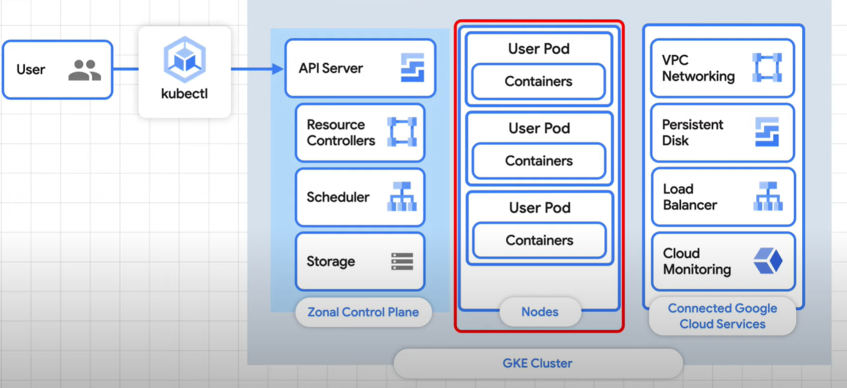
  + Zonal Control Plane – the managed architecture for actually running the K8s clusters
  + Nodes – the resources that your apps are running on such CPUs, memory and storage
  + Connected Google Cloud Services – There’s also a few other things that will affect your costs like networking and resource location.

## 2. Monitoring your GKE costs - https://youtu.be/lC7LSUlZ4A8

* a platform & infrastructure team that manages the clusters, which can be completely separate from the dev team.
* When every team understands the cost implications for the decisions they make, like how many resources an app actually needs, they can all work together to get things optimized.
* So where do you start? Well, that's probably going to be the monitoring dashboard.
  + When using GKE, the cluster's Info page shows a lot of details.
    - 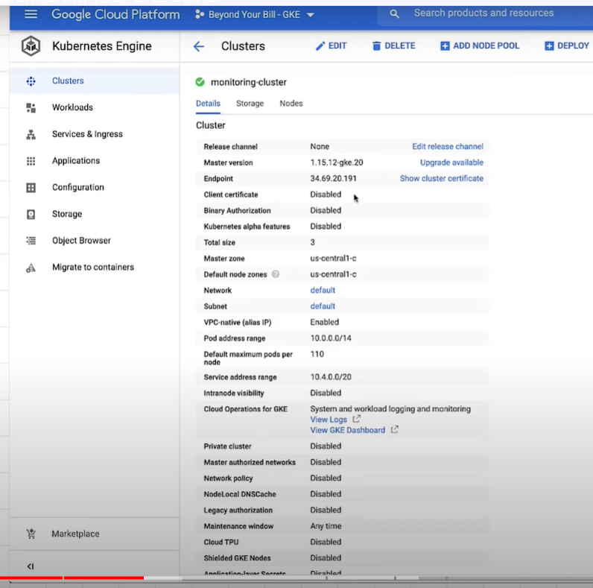
  + the Monitoring page. This is part of Cloud Operations, which has a bunch of helpful functionality for monitoring, logging, and alerting.
  + first time using Cloud Operations, a workspace created for you or you can create one manually.
    - 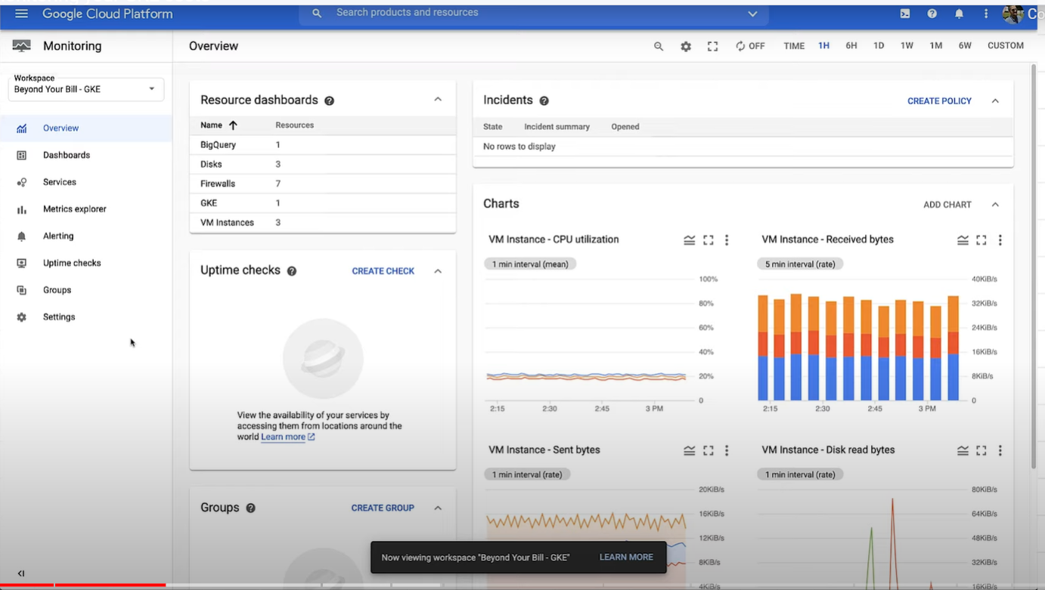
  + cluster s set up with Cloud Operations for GKE, a dashboard will automatically be created, named "GKE."
    - 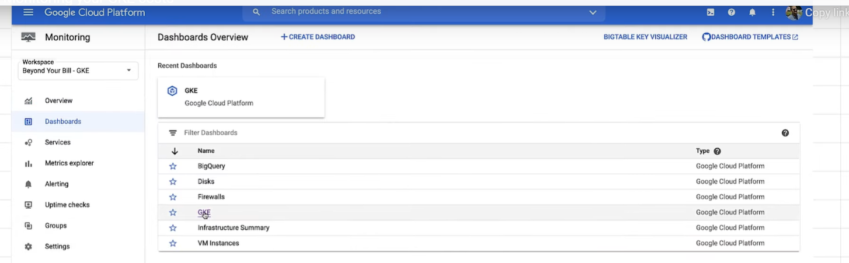
  + This dashboard gives us the ability to see our Kubernetes information over a time series, grouped by cluster, node, pod, and container.
  + the Infrastructure tab, which is a perfect view to get more details on the CPU and memory utilization, and if there are any issues with the nodes.
    - 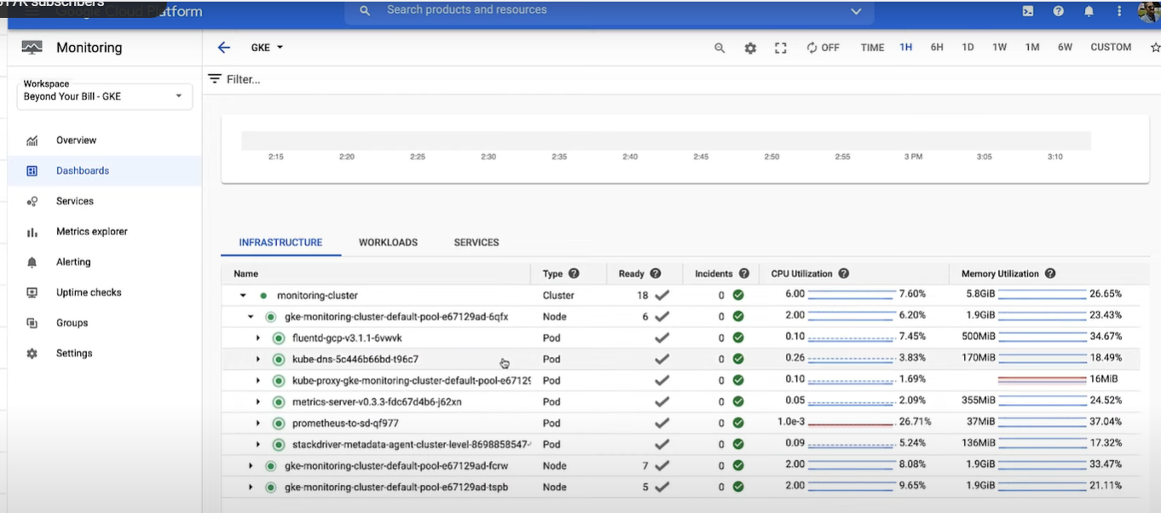
  + The Services tab gives the same information, but from a service-centric point of view--useful when there's a service disruption.
  + There's also a workload tab that gives you an app-centric view. This view is a helpful way to get an idea of what's going on,but we can also get more detail by using the Metrics Explorer.
    - 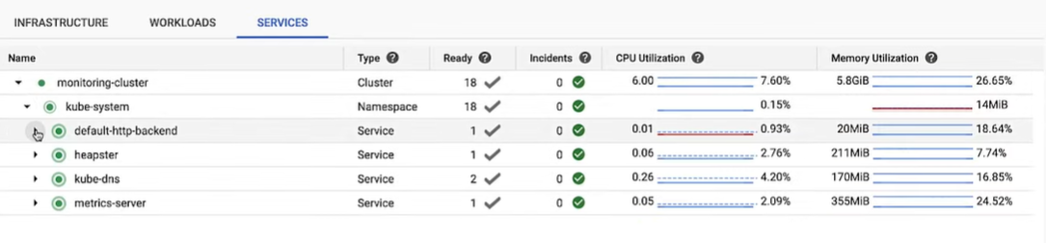
  + Here, we can create custom charts with options to filter, group, and aggregate.
  + For instance, we can create a chart that would let us see the CPU usage time by container.
  + You can even create a custom dashboard that shows more custom charts.
    - 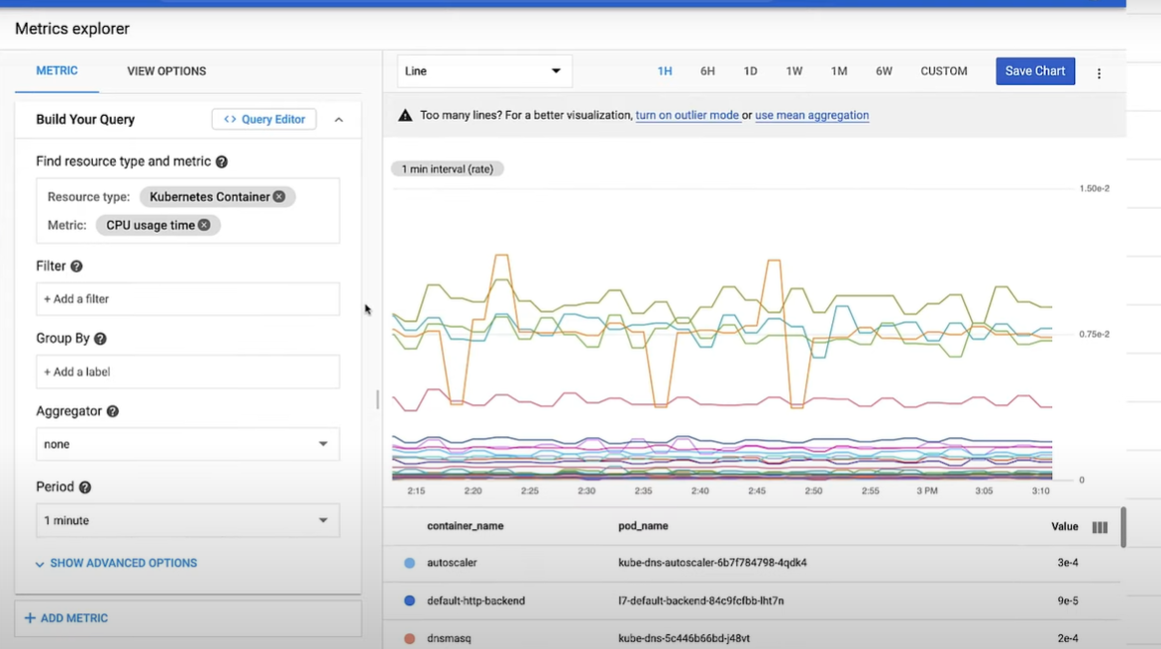
  + If you use Cloud Logging and Cloud Monitoring to provide observability into your apps and infrastructure, you're only paying for what you use.
  + However, the more that they log and the longer you keep those logs, the more that you'll pay for them.
  + Plus, the more external and custom metrics you have, the more you'll pay for those, as well.
  + <https://cloud.google.com/architecture/best-practices-for-running-cost-effective-kubernetes-applications-on-gke?utm_source=youtube&utm_medium=unpaidsoc&utm_campaign=CDR_mir_aap-serverless_lc7lsulz4a8_BeyondYourBill_111720&utm_content=description>
  + Using multi-tenant clusters, make sure that you're sending the logs back to the tenants for their usage.
  + The cost savings tip here is to use exclusion rules so that you can filter out the logs you don't care about before you get charged for them.
    - 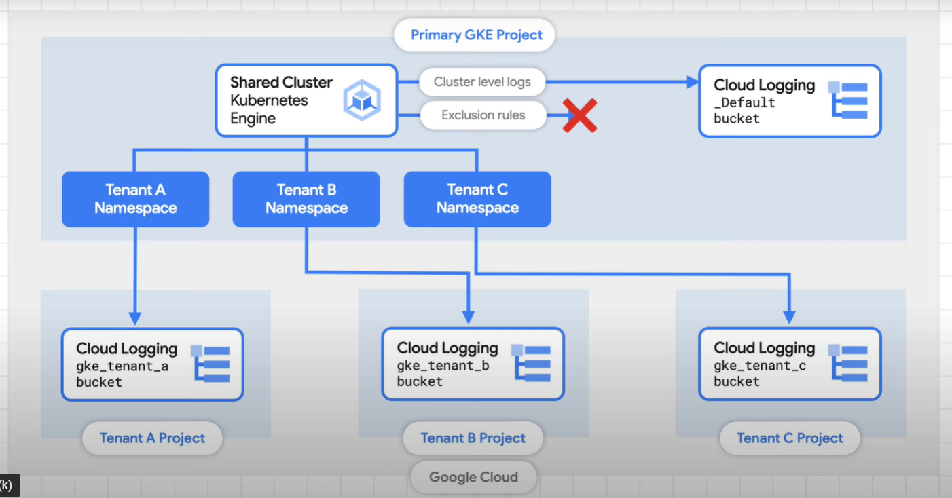03:19
  + Get even more granular, enable GKE Usage Monitoring to set up automatic collection of metrics, and then export then the BigQuery. to see specific usage of CPUs, GPUs, TPUs, memory, storage, and even network egress.
  + These details can be used to compare actual usage versus allocated resources, and then you can figure out where you might be over-allocated.
    - 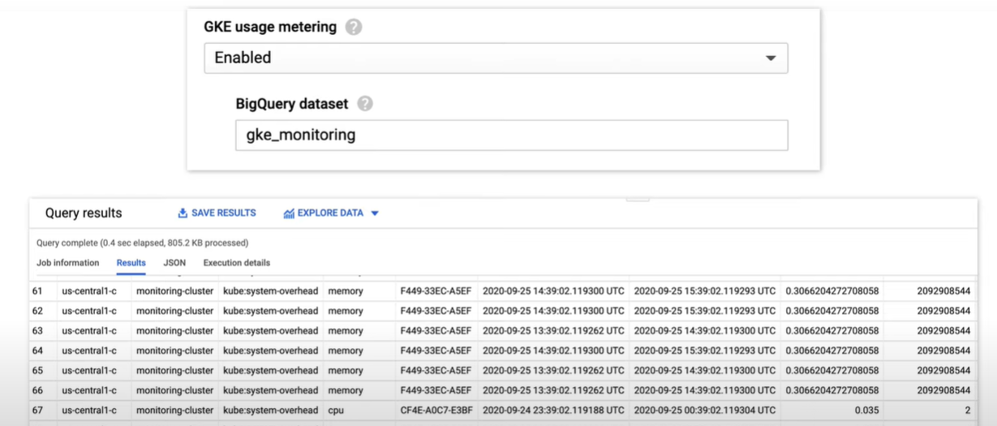
  + Following the best practice of splitting teams or apps by namespace also gives you the ability to easily see the resource usage and cost for each one. Labels can also be used for filtering.
    - 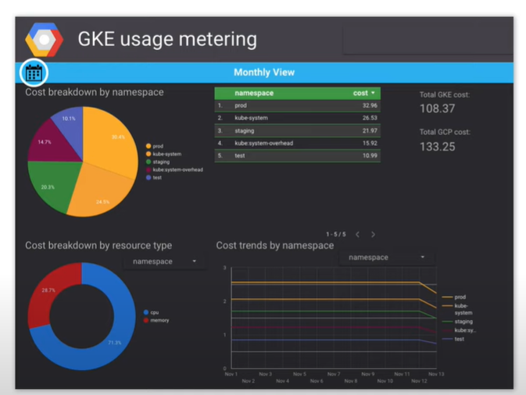04:13
  + Remember, high cost doesn't automatically mean that something is wrong, but you don't want to pay for things that you're not using.
  + use Kubernetes Resource Quotas, to see exactly how resources are being used,
  + Resource Quotas let you cap the amount of resources that a namespace can use. It can help you keeping any tenant from consuming too many resources, which might then trigger auto-scaling.
    - 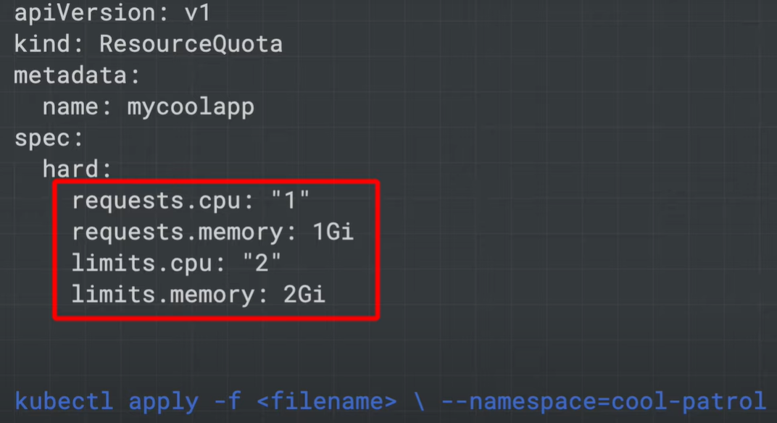
  + Limit ranges are another way to enforce resource limitations, but they're actually at a pod and cluster level.
    - 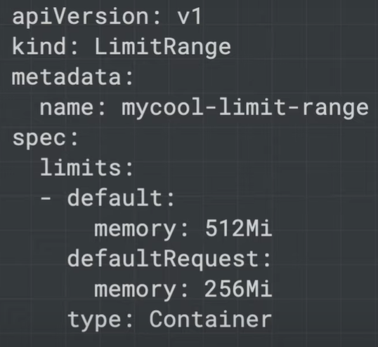
  + If Kubernetes supports a metrics server. It helps collect & then expose metrics to the K8ss metrics API.
  + When an application is using a lot of resources, It can be used to figure out when you should auto-scale.
  + but It’s still a deployment itself, which means that it actually needs to be running somewhere.
  + As a cluster gets more nodes and deployments, the metric server needs to grow along with it.
  + However, when it's time for the metric server to grow, it has to be restarted.
  + If your cluster is changing quickly, this could mean a lot of restarts, which could then cause a small delay in auto-scalers, and even small delays in auto-scaling can add up to big impact.
    - 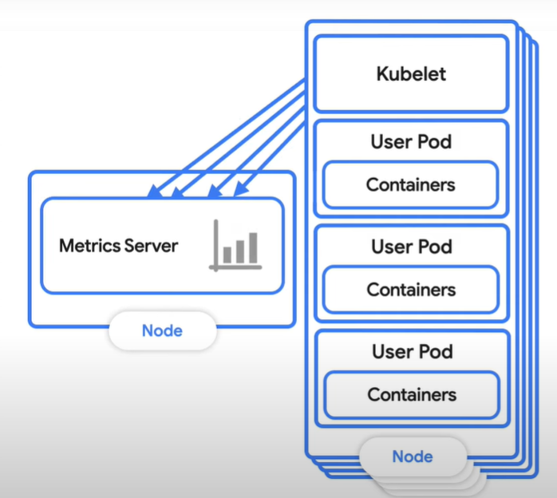
  + Newer versions of GKE support a resize delay to help keep your metric server from restarting as often, make sure that your version supports the scale-down delay to avoid too many restarts, and ensure that you monitor the metric server as a top priority to avoid potential auto-scaling issues.
    - 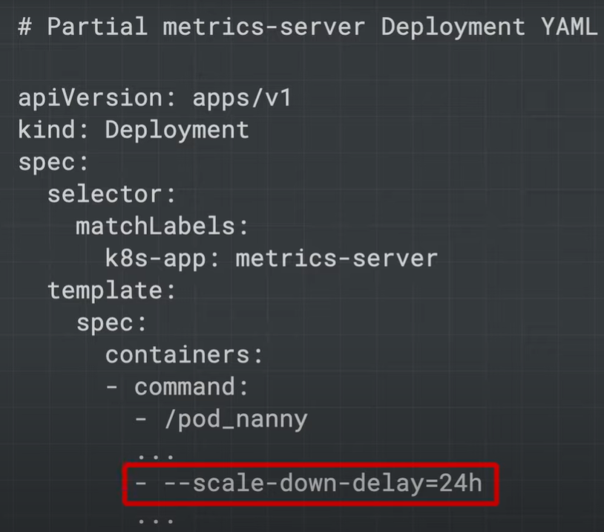
  + The Anthos Policy Controller is one way to help automate this by checking, auditing, and enforcing those policies that you've created. These policies can help you control security, regulations, and custom business logic that might affect your costs or your application stability.
    - 
  + Use a tool like KPT to build this logic into your CI/CD pipeline, so you're automatically validating any configurations through the development cycle.
    - 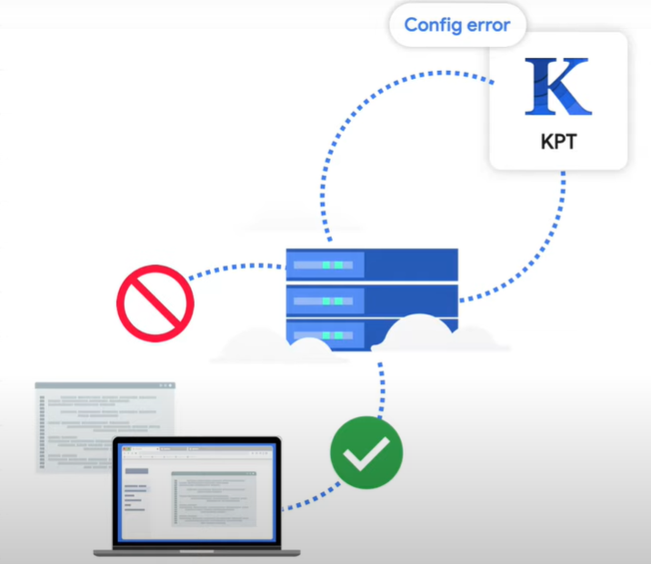
  + Watch the Recommendation Hub. All kinds of recommendations come up here, from security to cost.
    - 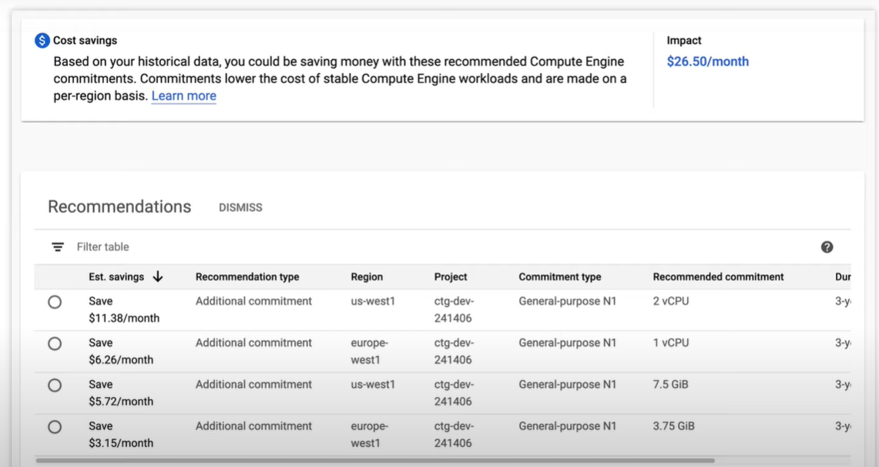

## 3. Managing a GKE Multi-tenant Cluster with Namespaces - https://www.cloudskillsboost.google/focuses/14861?parent=catalog

* Overview
  + When considering cost optimization solutions for any Google Cloud infrastructure built around Google Kubernetes Engine (GKE) clusters, it's important to ensure that you're making effective use of the resources that are being billed. A common misstep is assigning a one to one ratio of users or teams to clusters, resulting in cluster proliferation.
  + A **multi-tenancy cluster** allows for multiple users or teams to share one cluster for their workloads while maintaining isolation and fair resource sharing. This is achieved by creating **namespaces**. Namespaces allow multiple virtual clusters to exist on the same physical cluster.
  + In this lab you will learn how to set up a multi-tenant cluster using multiple namespaces to optimize resource utilization and, in effect, optimize costs.
* What you'll do
  + Create multiple namespaces in a GKE cluster
  + Configure role-based access control for namespace access
  + Configure Kubernetes resource quotas for fair sharing resources across multiple namespaces
  + View and configure monitoring dashboards to view resource usage by namespace
  + Generate a GKE metering report in Data Studio for fine grained metrics on resource utilization by namespace
* Download required files
  + In this lab, some steps will use yaml files to configure your Kubernetes cluster. In your Cloud Shell, download these files from a Cloud Storage bucket:
    - gsutil -m cp -r gs://spls/gsp766/gke-qwiklab ~
  + Change your current working directory to gke-qwiklab:
    - cd ~/gke-qwiklab
* View and Create Namespaces
  + Run the following to set a default compute zone and authenticate the provided cluster multi-tenant-cluster:
  + gcloud config set compute/zone us-central1-a && gcloud container clusters get-credentials multi-tenant-cluster
  + Default namespaces
    - By default, Kubernetes clusters have 4 system namespaces. You can get a full list of the current cluster's namespaces with:
      * kubectl get namespace
    - The output should be similar to:
      * NAME STATUS AGE
      * default Active 5m
      * kube-node-lease Active 5m
      * kube-public Active 5m
      * kube-system Active 5m
      * **default** - the default namespace used when no other namespace is specified
      * **kube-node-lease** - manages the lease objects associated with the heartbeats of each of the cluster's nodes
      * **kube-public** - to be used for resources that may need to be visible or readable by all users throughout the whole cluster
      * **kube-system** - used for components created by the Kubernetes system
    - Not everything belongs to a namespace. For example, nodes, persistent volumes, and namespaces themselves do not belong to a namespace. For a complete list of namespaced resources:
      * kubectl api-resources --namespaced=true
    - When they are created, namespaced resources must be associated with a namespace. This is done by including the --namespace flag or indicating a namespace in the yaml's metadata field. The namespace can also be specified with any kubectl get subcommand to display a namespace's resources. For example:
      * kubectl get services --namespace=kube-system
    - This will output all services in the kube-system namespace.

### Creating New Namespaces

* + - Note: When creating additional namespaces, avoid prefixing the names with ‘kube' as this is reserved for system namespaces.
    - Create 2 namespaces for team-a and team-b:
      * kubectl create namespace team-a && \
      * kubectl create namespace team-b
    - By specifying the --namespace tag, you can create cluster resources in the provided namespace. Names for resources, such as deployments or pods, only need to be unique within their respective namespaces.
    - As an example, run the following to deploy a pod in the team-a namespace and in the team-b namespace using the same name:
      * kubectl run app-server --image=centos --namespace=team-a -- sleep infinity && \
      * kubectl run app-server --image=centos --namespace=team-b -- sleep infinity
    - Using kubectl get pods -A to see there are 2 pods named app-server, one for each team namespace:
      * kubectl get pods -A
    - (Output)
      * NAMESPACE NAME READY STATUS RESTARTS AGE
      * kube-system event-exporter-gke-8489df9489-k2blq 2/2 Running 0 3m41s
      * kube-system fluentd-gke-fmt4v 2/2 Running 0 113s
      * kube-system fluentd-gke-n9dvn 2/2 Running 0 79s
      * kube-system fluentd-gke-scaler-cd4d654d7-xj78p 1/1 Running 0 3m37s
      * kube-system gke-metrics-agent-4jvn8 1/1 Running 0 3m33s
      * kube-system gke-metrics-agent-b4vvw 1/1 Running 0 3m27s
      * kube-system kube-dns-7c976ddbdb-gtrct 4/4 Running 0 3m41s
      * kube-system kube-dns-7c976ddbdb-k9bgk 4/4 Running 0 3m
      * kube-system kube-dns-autoscaler-645f7d66cf-jwqh5 1/1 Running 0 3m36s
      * kube-system kube-proxy-gke-new-cluster-default-pool-eb9986d5-tpql 1/1 Running 0 3m26s
      * kube-system kube-proxy-gke-new-cluster-default-pool-eb9986d5-znm6 1/1 Running 0 3m33s
      * kube-system l7-default-backend-678889f899-xvt5t 1/1 Running 0 3m41s
      * kube-system metrics-server-v0.3.6-64655c969-jtl57 2/2 Running 0 3m
      * kube-system prometheus-to-sd-d6dpf 1/1 Running 0 3m27s
      * kube-system prometheus-to-sd-rfdlv 1/1 Running 0 3m33s
      * kube-system stackdriver-metadata-agent-cluster-level-79f9ddf6d6-7ck2w 2/2 Running 0 2m56s
      * team-a app-server 1/1 Running 0 33s
      * team-b app-server 1/1 Running 0 33s
    - Use kubectl describe to see additional details for each of the newly created pods by specifying the namespace with the --namespace tag:
      * kubectl describe pod app-server --namespace=team-a
    - To work exclusively with resources in one namespace, you can set it once in the kubectl context instead of using the --namespace flag for every command:
      * kubectl config set-context --current --namespace=team-a
    - After this, any subsequent commands will be run against the indicated namespace without specifying the --namespace flag:
      * kubectl describe pod app-server
    - In the next section, you will configure role-based access control for your namespaces to help organize the cluster.
* Access Control in Namespaces
  + Provisioning access to namespaced resources in a cluster is accomplished by granting a combination of IAM roles and Kubernetes' built-in role-based access control (RBAC). An IAM role will give an account initial access to the project while the RBAC permissions will grant granular access to a cluster's namespaced resources (pods, deployments, services, etc).
  + IAM Roles
    - To grant IAM roles in a project, you'll need the Project IAM Admin role assigned. This is already set up in your Qwiklabs temporary account.
    - When managing access control for Kubernetes, Identity and Access Management (IAM) is used to manage access and permissions on a higher organization and project levels.
    - There are several roles that can be assigned to users and service accounts in IAM that govern their level of access with GKE. RBAC's granular permissions build on the access already provided by IAM and cannot restrict access granted by it. As a result, for multi-tenant namespaced clusters, the assigned IAM role should grant minimal access.
    - Here's a table of common GKE IAM roles you can assign:

|  |  |
| --- | --- |
| * Role | * Description |
| * **Kubernetes Engine Admin** | * Provides access to full management of clusters and their Kubernetes API objects. A user with this role will be able to create, edit and delete any resource in **any** cluster and subsequent namespaces. |
| * **Kubernetes Engine Developer** | * Provides access to Kubernetes API objects inside clusters. A user with this role will be able to create, edit, and delete resources in **any** cluster and subsequent namespaces. |
| * **Kubernetes Engine Cluster Admin** | * Provides access to management of clusters. A user with this role will not have access to create or edit resources within any cluster or subsequent namespaces directly, but will be able to create, modify, and delete any cluster. |
| * **Kubernetes Engine Viewer** | * Provides read-only access to GKE resources. A user with this role will have read-only access to namespaces and their resources. |
| * **Kubernetes Engine Cluster Viewer** | * Get and list access to GKE Clusters. This is the minimal role required for anyone who needs to access resources within a cluster's namespaces. |

* + - While most of these roles grant too much access to restrict with RBAC, the IAM role **Kubernetes Engine Cluster Viewer** gives users just enough permissions to access the cluster and namespaced resources.
    - Your lab project has a service account that will represent a developer that will use the team-a namespace. Grant the account the Kubernetes Engine Cluster Viewer role by running the following:
      * gcloud projects add-iam-policy-binding ${GOOGLE_CLOUD_PROJECT} --member=serviceAccount:team-a-dev@${GOOGLE_CLOUD_PROJECT}.iam.gserviceaccount.com --role=roles/container.clusterViewer
  + Kubernetes RBAC
    - Within a cluster, access to any resource type (pods, services, deployments, etc) is defined by either a **role** or a **cluster role**. Only **roles** are allowed to be scoped to a namespace. While a role will indicate the resources and the action allowed for each resource, a **role binding** will indicate to what user accounts or groups to assign that access to.
    - To create a role in the current namespace, specify the resource type as well as the verbs that will indicate what type of action that will be allowed. Roles with single rules can be created with kubectl create:
      * kubectl create role pod-reader --resource=pods --verb=watch --verb=get --verb=list
    - Roles with multiple rules can be created using a yaml file. An example file is provided within the files you downloaded earlier in the lab.
    - Inspect the yaml file:
      * cat developer-role.yaml

apiVersion: rbac.authorization.k8s.io/v1

kind: Role

metadata:

namespace: team-a

name: developer

rules:

- apiGroups: [""]

resources: ["pods", "services", "serviceaccounts"]

verbs: ["update", "create", "delete", "get", "watch", "list"]

- apiGroups:["apps"]

resources: ["deployments"]

verbs: ["update", "create", "delete", "get", "watch", "list"]

* + - Apply the role above:
      * kubectl create -f developer-role.yaml
    - Create a role binding between the team-a-developers serviceaccount and the developer-role:
      * kubectl create rolebinding team-a-developers --role=developer --user=team-a-dev@${GOOGLE_CLOUD_PROJECT}.iam.gserviceaccount.com
  + Test the rolebinding
    - Download the service account keys used to impersonate the service account:
      * gcloud iam service-accounts keys create /tmp/key.json --iam-account team-a-dev@${GOOGLE_CLOUD_PROJECT}.iam.gserviceaccount.com
    - In Cloud Shell click the + to open a new tab in your terminal. Here, run the following to activate the service account. This will allow you to run the commands as the account:
      * gcloud auth activate-service-account --key-file=/tmp/key.json
    - Get the credentials for your cluster, as the service account:
      * gcloud container clusters get-credentials multi-tenant-cluster --zone us-central1-a --project ${GOOGLE_CLOUD_PROJECT}
    - You'll see now that as team-a-dev you're able to list pods in the team-a namespace:
      * kubectl get pods --namespace=team-a
    - Output:
    - NAME READY STATUS RESTARTS AGE
    - app-server 1/1 Running 0 6d
    - But listing pods in the team-b namespace is restricted:
      * kubectl get pods --namespace=team-b
    - Output:
    - Error from server (Forbidden): pods is forbidden: User "team-a-dev@a-gke-project.iam.gserviceaccount.com" cannot list resource "pods" in API group "" in the namespace "team-b": requires one of ["container.pods.list"] permission(s).
    - Return to your first Cloud Shell tab or open a new one. Renew the cluster credentials and reset your context to the team-a namespace:
      * gcloud container clusters get-credentials multi-tenant-cluster --zone us-central1-a --project ${GOOGLE_CLOUD_PROJECT}
* Resource Quotas
  + When a cluster is shared in a multi-tenant set up, it's important to make sure that users are not able to use more than their fair share of the cluster resources. A resource quota object (ResourceQuota) will define constraints that will limit resource consumption in a namespace. A resource quota can specify a limit to object counts (pods, services, stateful sets, etc), total sum of storage resources (persistent volume claims, ephemeral storage, storage classes ), or total sum of compute resources. (cpu and memory).
  + For example, the following will set a limit to the number of pods allowed in the namespace team-a to 2, and the number of loadbalancers to 1:
    - kubectl create quota test-quota --hard=count/pods=2,count/services.loadbalancers=1 --namespace=team-a
  + Create a second pod in the namespace team-a:
    - kubectl run app-server-2 --image=centos --namespace=team-a -- sleep infinity
  + Now try to create a third pod:
    - kubectl run app-server-3 --image=centos --namespace=team-a -- sleep infinity
  + You should receive the following error:
    - Error from server (Forbidden): pods "app-server-3" is forbidden: exceeded quota: test-quota, requested: count/pods=1, used: count/pods=2, limited: count/pods=2
  + You can check details about your resource quota using kubectl describe:
    - kubectl describe quota test-quota --namespace=team-a
  + Output:
    - Name: test-quota
    - Namespace: team-a
    - Resource Used Hard
    - -------- ---- ----
    - count/pods 2 2
    - count/services.loadbalancers 0 1
  + Here you can see a list of resources restricted by the resource quota, along with the hard limit configured and the quantity currently used.
  + Update test-quota to have a limit of 6 pods by running:
    - export KUBE_EDITOR="nano"
    - kubectl edit quota test-quota --namespace=team-a
  + You'll be able to edit a yaml file that kubectl will use to update the quota. The hard quota is the value for count/pods under spec.
  + Change the value of count/pods under spec to **6**:

apiVersion: v1

kind: ResourceQuota

metadata:

creationTimestamp: "2020-10-21T14:12:07Z"

name: test-quota

namespace: team-a

resourceVersion: "5325601"

selfLink: /api/v1/namespaces/team-a/resourcequotas/test-quota

uid: a4766300-29c4-4433-ba24-ad10ebda3e9c

spec:

hard:

count/pods: "6"

count/services.loadbalancers: "1"

status:

hard:

count/pods: "5"

count/services.loadbalancers: "1"

used:

count/pods: "2"

* + Press **ctrl + X**, **Y** and **Enter** to save and exit.
  + The updated quota should now be reflected in the output:
    - kubectl describe quota test-quota --namespace=team-a
  + (output)
    - Name: test-quota
    - Namespace: team-a
    - Resource Used Hard
    - -------- ---- ----
    - count/pods 2 6
    - count/services.loadbalancers 0 1
  + **CPU and Memory Quotas**
    - When setting quotas for CPU and memory, you can indicate a quota for the sum of requests (a value that a container is guaranteed to get) or the sum of limits (a value that a container will never be allowed to pass).
    - In this lab, your cluster has 4 n1-standard-1 machines, with 1 core and 3.75GB memory each. You have been provided with a sample resource quota yaml file for your cluster:
    - cpu-mem-quota.yaml

apiVersion: v1

kind: ResourceQuota

metadata:

name: cpu-mem-quota

namespace: team-a

spec:

hard:

limits.cpu: "4"

limits.memory: "12Gi"

requests.cpu: "2"

requests.memory: "8Gi"

* + - Apply the file configuration:
    - Make sure you're still in the **gke-qwiklab** directory.
      * kubectl create -f cpu-mem-quota.yaml
    - With this quota in place, the sum of all pods' CPU and memory requests will be capped at 2cpu and 8GiB, and their limits at 4cpu and 12GiB, respectively.
    - Note: When a resource quota for CPU or memory exists in a namespace, every container that is created in that namespace thereafter must have its own CPU and memory limit defined on creation or by having a default value assigned in the namespace as a LimitRange.
    - To demonstrate the CPU and memory quota, create a new pod using cpu-mem-demo-pod.yaml:
    - cpu-mem-demo-pod.yaml:

apiVersion: v1

kind: Pod

metadata:

name: cpu-mem-demo

namespace: team-a

spec:

containers:

- name: cpu-mem-demo-ctr

image: nginx

resources:

requests:

cpu: "100m"

memory: "128Mi"

limits:

cpu: "400m"

memory: "512Mi"

* + - Apply the file configuration:
      * kubectl create -f cpu-mem-demo-pod.yaml --namespace=team-a
    - Once this pod has been created, run the following to see its CPU and memory requests and limits reflected in the quota:
      * kubectl describe quota cpu-mem-quota --namespace=team-a
    - (output)
      * Name: cpu-mem-quota
      * Namespace: team-a
      * Resource Used Hard
      * -------- ---- ----
      * limits.cpu 400m 4
      * limits.memory 512Mi 12Gi
      * requests.cpu 100m 2
      * requests.memory 128Mi 8Gi
* Monitoring GKE and GKE Usage Metering
  + For most multi-tenant clusters, it's likely that the workloads and resource requirements of each of the tenants will change and resource quotas might need to be adjusted. By using Monitoring you can get a general view of the resources each namespace is using.
  + With GKE usage metering, you're able to get a more granular view of that resource usage and subsequently a better idea of costs associated with each tenant.
  + **Monitoring Dashboard**
    - In the Cloud Console, click on the **Navigation menu** at the top left corner of the page and then click **Operations** > **Monitoring** within that menu.
    - Wait a minute while your workspace for your project is constructed. Once you're on the Overview page, select **Dashboards** from the left menu:
    - Select **GKE** from the Dashboards Overview page. The GKE Dashboard presents you with a collection of tables detailing CPU, memory, and disk utilization aggregated by several resources.
    - For example, the Namespaces table will show you utilization for each of your clusters' namespaces:
      * 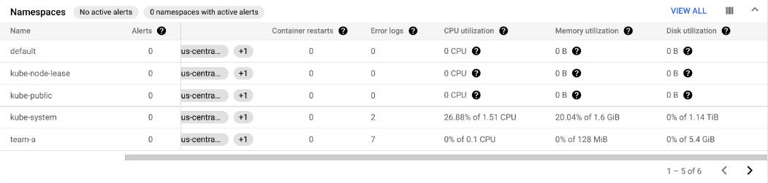
    - You can also get a look at the utilization data for the workloads running on your cluster in the Workloads table. Click **View All** and in the ADD FILTER box select **Namespaces** > **team-a**. Then, click **Apply**.
    - This will filter workloads to include only those running on the team-a namespace:
      * 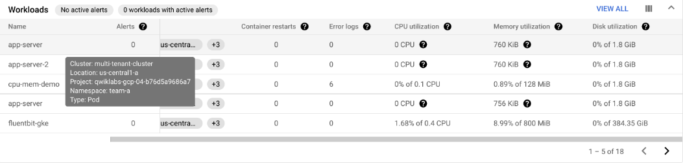
      * 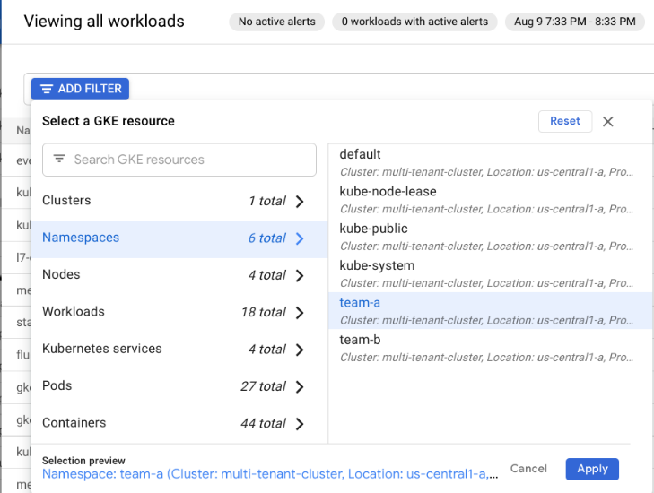
  + **Metrics Explorer**
    - From the left-side pane select **Metrics Explorer:**
    - Enter **Kubernetes Container** as your resource type and select **CPU usage time** as the metric.
    - Type **cp** into the metric field and you should see CPU usage time appear as an option in a dropdown menu.
    - To exclude the kube-system namespace, click **Add a filter** in the filter section and select namespace_name. Select **!=** as the operator and kube-system as the value.
    - Next, in the **Group By** field enter **namespace_name** and click **OK**. What you'll see is a graph showing container CPU usage time by namespace:
      * 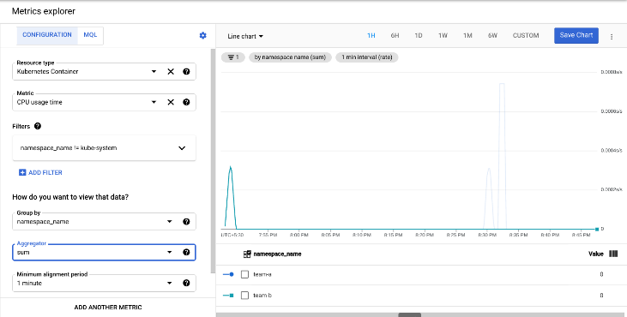
  + **GKE usage metering**
    - GKE usage metering allows you to export your GKE cluster resource utilization and consumption to a BigQuery dataset where you can visualize it using Data Studio. It allows for a more granular view of resource usage. By using usage metering, you are able to make more informed decisions on resource quotas and efficient cluster configuration.
    - Note: Because it can take several hours for GKE metric data to populate BigQuery, your lab project includes BigQuery datasets with simulated resource usage and billing data for demonstrative purposes.
    - The following two datasets have been added to your project:
    - **cluster_dataset** - this is a dataset manually created before enabling GKE usage metering on the cluster. This dataset contains 2 tables generated by GKE (gke_cluster_resource_consumption and gke_cluster_resource_usage) and is continuously updated with cluster usage metrics.
    - **billing_dataset**- this is a dataset manually created before enabling BigQuery export for billing. This dataset contains 1 table (gcp_billing_export_v1_xxxx) and is updated each day with daily costs of a project.
    - Run the following to enable GKE usage metering on the cluster and specify the dataset cluster_dataset:
      * gcloud container clusters update multi-tenant-cluster --zone us-central1-a --resource-usage-bigquery-dataset cluster_dataset
  + Create the GKE cost breakdown table
    - A cost_breakdown table can be generated from the billing and resource usage tables in your project. You'll generate this table in the cluster dataset using the file usage_metering_query_template.sql. This template is available through [the documentation page for cluster usage metering](https://cloud.google.com/kubernetes-engine/docs/how-to/cluster-usage-metering#create_the_cost_breakdown_table).
    - First, in Cloud Shell, set some environment variables.
    - Set the path of the provided billing table, the provided usage metering dataset, and a name for the new cost breakdown table:
      * export GCP_BILLING_EXPORT_TABLE_FULL_PATH=${GOOGLE_CLOUD_PROJECT}.billing_dataset.gcp_billing_export_v1_xxxx
      * export USAGE_METERING_DATASET_ID=cluster_dataset
      * export COST_BREAKDOWN_TABLE_ID=usage_metering_cost_breakdown
    - Next, specify the path of the usage metering query template downloaded at the start of this lab, an output file for the usage metering query that will be generated, and a start date for the data (the earliest date in the data is 2020-10-26):
      * export USAGE_METERING_QUERY_TEMPLATE=~/gke-qwiklab/usage_metering_query_template.sql
      * export USAGE_METERING_QUERY=cost_breakdown_query.sql
      * export USAGE_METERING_START_DATE=2020-10-26
    - Now, using these env variables and the query template, generate the usage metering query:
      * sed \
      * -e "s/\${fullGCPBillingExportTableID}/$GCP_BILLING_EXPORT_TABLE_FULL_PATH/" -e "s/\${projectID}/$GOOGLE_CLOUD_PROJECT/" -e "s/\${datasetID}/$USAGE_METERING_DATASET_ID/" -e "s/\${startDate}/$USAGE_METERING_START_DATE/" "$USAGE_METERING_QUERY_TEMPLATE" > "$USAGE_METERING_QUERY"
    - Run the cmd to set up your cost breakdown table using the qry you rendered in the previous step:

bq query \

--project_id=$GOOGLE_CLOUD_PROJECT \

--use_legacy_sql=false \

--destination_table=$USAGE_METERING_DATASET_ID.$COST_BREAKDOWN_TABLE_ID \

--schedule='every 24 hours' \

--display_name="GKE Usage Metering Cost Breakdown Scheduled Query" \

--replace=true \

"$(cat $USAGE_METERING_QUERY)"

* + - Data Transfer should provide a link for authorization. Click it, log in with your student account, follow the instructions, and paste the version_info back in your Cloud Shell.
    - Afterwards, this should return a message indicating that the transfer configuration has been successfully created.
  + Create the data source in Data Studio
    - Click the link below to navigate to the Data Studio Data Sources page:
    - [Data Sources](https://datastudio.google.com/c/navigation/datasources)
    - You will see an Overview page. Click on **HOME** and select your Qwiklabs account.
    - On the top left click **Create** > **Data Source** to add a new data source.
    - You'll first be presented with the **To get started, let's complete your account setup** window.
    - Check the acknowledgement box and then click **Continue**.
    - Select **No** for each Tip and Recommendation as this is a temporary lab/account.
    - Click **Continue**.
    - You'll be presented with a list of Google Connectors that are supported by Data Studio. Select BigQuery from the list.
      * 
    - Click the **Authorize** button to allow Data Studio to access your BigQuery project.
    - At the top left of the page, rename your data source from Untitled Data Source to GKE Usage.
    - From the first column, select **CUSTOM QUERY**.
    - Select your **project ID** from the projects column.
    - Enter the following qry in the custom query box and replace [PROJECT-ID]:
      * SELECT * FROM `[PROJECT-ID].cluster_dataset.usage_metering_cost_breakdown`
    - Click **CONNECT**.
    - Next, click at the top right. Now that the data source has been added, it's time to use it to create a report. At the top of your data source page, click **CREATE REPORT**.
      * 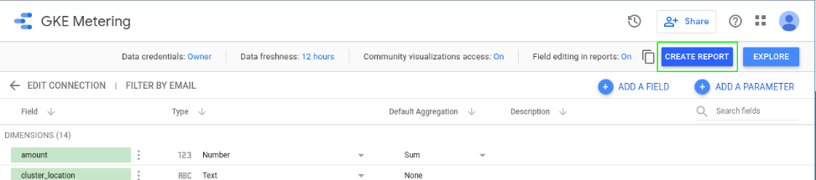
    - NOTE: If you get an error at this point, your Data Transfer job may not have completed yet. Wait a minute and try again.
    - When creating a new report from a data source, you'll be prompted to add data to your report. Click **ADD TO REPORT**:
      * 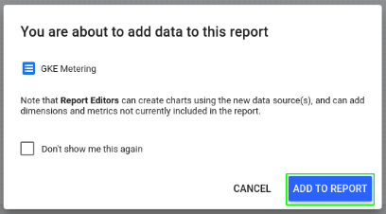
  + Create a Data Studio Report
    - The report will be where you'll be able to visualize the usage metrics from the data source based on your BigQuery table.
    - You'll start out with a simple table:
      * 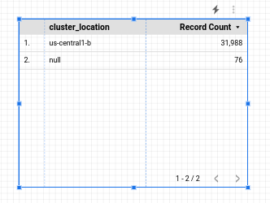
    - You'll configure this table to show a cost breakdown by namespace. With the table selected, you'll see data related to it on the panel to the right.
    - Change the following in that panel:
      * **Data Range Dimension:** usage_start_time
      * **Dimension:** namespace
      * **Metric:** cost
    - Leave all other fields with their default values.
    - To limit your table to namespaced resources you can apply a filter. In the data panel click **Add a Filter** under the Filter section. Create a filter that will exclude resources unallocated to a namespace:
      * 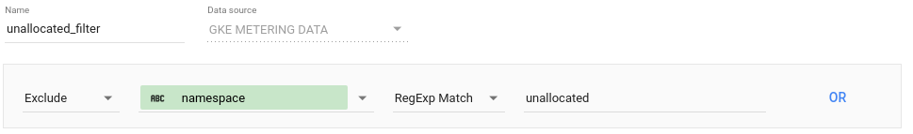
    - Click **Save**.
    - Click **Add a Filter** again and **Create a Filter** to create a second filter which will limit the data to requests:
      * 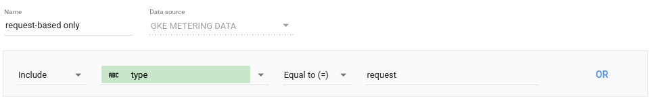
    - Click **Save** to apply the filter. The resulting table should look like this:
      * 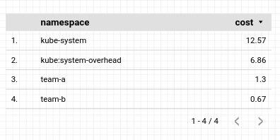
    - Next, you'll add a pie chart to your report that shows the cost breakdown by namespace. Right click the table you created and select **Duplicate**. Drag the duplicate table object anywhere on your report.
    - Next, click the header of the configuration panel:
      * 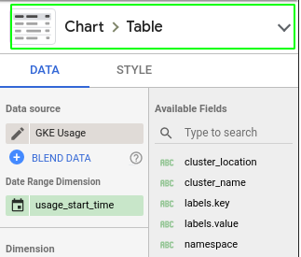
    - From the options presented, click the **pie chart** icon:
      * 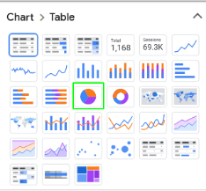
    - The resulting pie chart will look like this:
      * 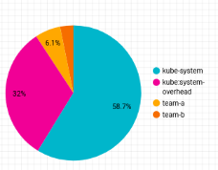
    - Next, you'll add a donut chart that will show the cost breakdown by resource type. From the top toolbar click **Add a chart** and select  (Donut) to create a donut chart. Drag the chart anywhere on your report, and configure it with the following:
      * **Data Range Dimension:** usage_start_time
      * **Dimension:** resource_name
      * **Metric:** cost
    - Click **Add a Filter** and select the 2 filters you applied to the previous chart. The resulting donut chart will look like this:
      * 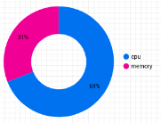
    - To add a breakdown by namespace, from the top toolbar click **Add a control** and select **Drop-down list**. Drag it next to your donut chart and configure it with the following:
      * **Data Range Dimension:** usage_start_time
      * **Control field:** namespace
      * **Metric:** None
    - Click **Add a filter** and select **unallocated_filter** from the list.
    - In order to configure the control to affect only the donut chart, select both the control object and the donut chart using the selector cursor to draw a rectangle around both objects. Right click and select **Group** to bind them into a group:
      * 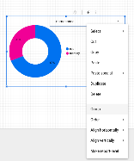
    - To preview your report, click **View** from the top toolbar. In view mode, you'll be able to adjust the view of your donut chart to a particular namespace:
      * 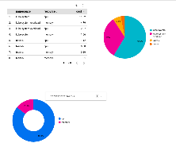
    - From the **Share** menu at the top of the page click **Download report** to download a copy of the full report as a PDF file:
      * 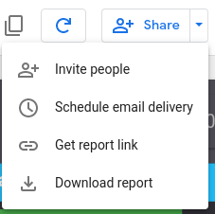

## 4. Virtual machines in GKE - https://youtu.be/qSadsjIDwCY

* 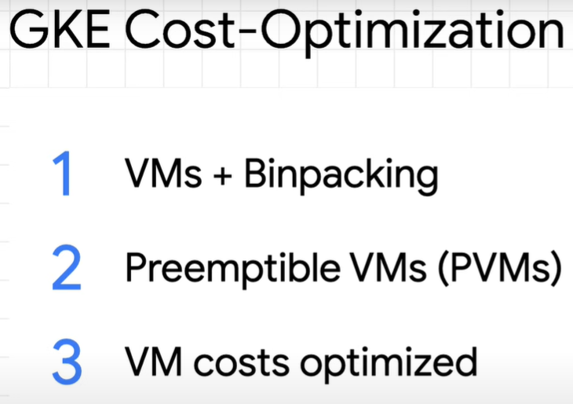
* Let's start with some general machine types.
  + 
  + The N-series machines were the default for most general workloads on Google Cloud. And they were a great combination of powerful and flexible.
  + the E-series or E2 came out as an updated general purpose machine type. It's a bit less flexible than the N-series, but it's also a bit cheaper.
  + 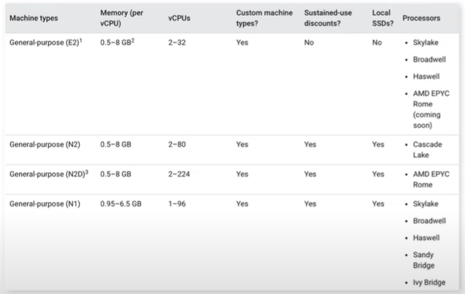
  + One example is that the N-series and E2 series have different sets of processors that are available.
  + E2s have similar performance to N1s, but they're optimized for cost.
  + 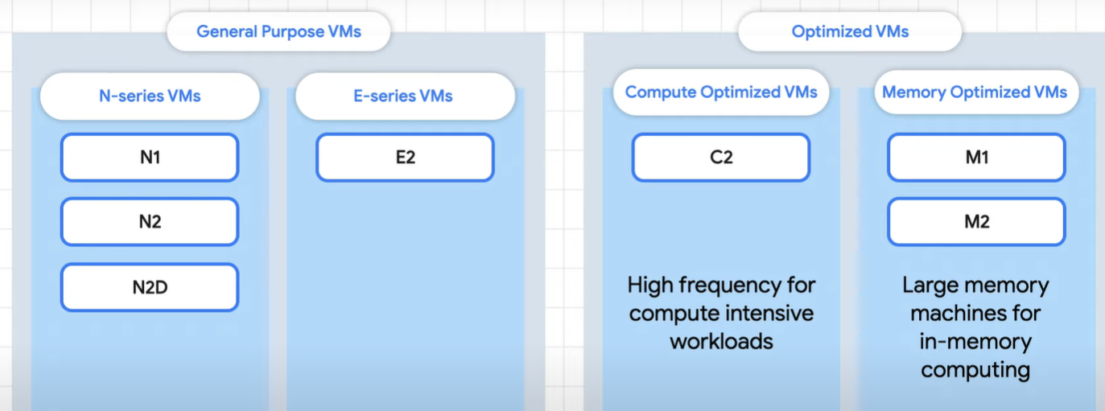
  + optimized to help run workloads that need that extra CPU or memory.
  + So maybe instead of spreading your deployments across a bunch of general machines, you could stack them onto fewer optimized machines.
  + 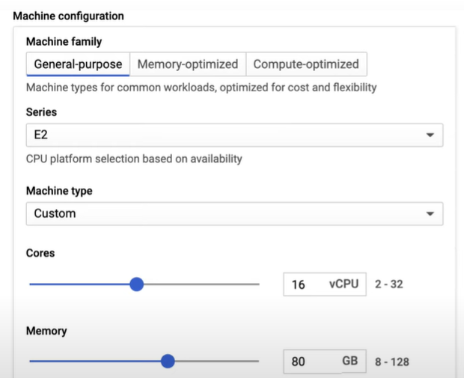
* In fact, all of this is known as binpacking.
  + It's all about making sure that you find the most efficient way to run apps on your machines and to minimize wasted space.
  + Kubernetes will try to find a node to schedule your pods. And if it can't find one, it'll add more nodes according to your node pool configuration.
  + Let's take a look at an example.
    - 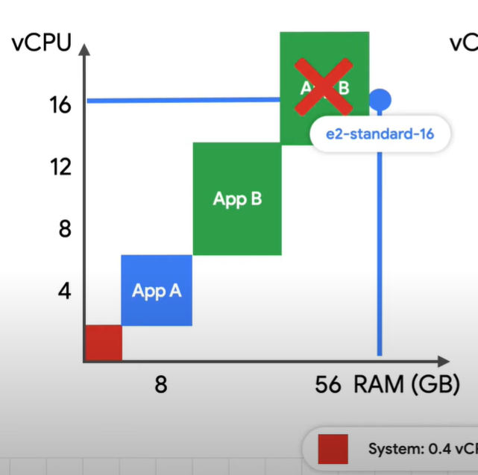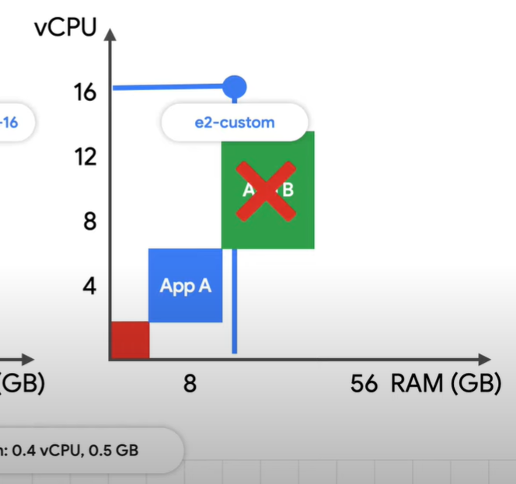
    - Here we have two machines, the E2-standard-16 with 16 vCPUS and 64 gigs of memory and a custom E2 with the same vCPUs but only 16 gigs of memory.
    - We also have two applications with different sizes, and app A has two replicas.
    - So what happens if Kubernetes needs to schedule 2 more replicas of app B?
    - The standard has enough memory but not enough vCPU.
    - On the custom, there is enough vCPU for one but not enough memory for any.
    - That means Kubernetes needs to make more nodes. And since two replicas of app B couldn't fit on a new standard, that means two more nodes and even more wasted space.
  + To help optimize usage, think about the size of our pods.
    - 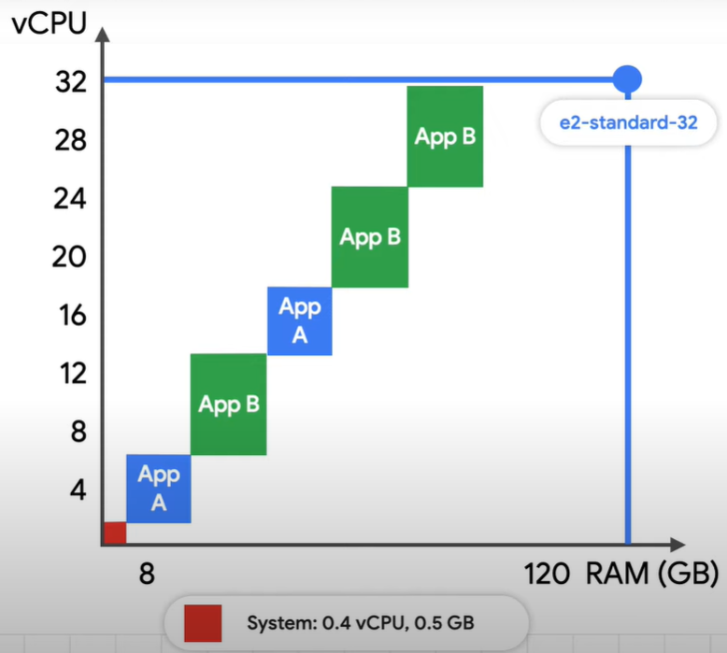
  + They're not all going to be the same size, but when we have a general sense of each application, we can optimize nodes around that.
  + And we can use larger machines to better binpack.
* The good news is that GKE offers node auto provisioning, which automatically figures out optimal machine sizes and then dynamically adds and removes node pools for you.
  + 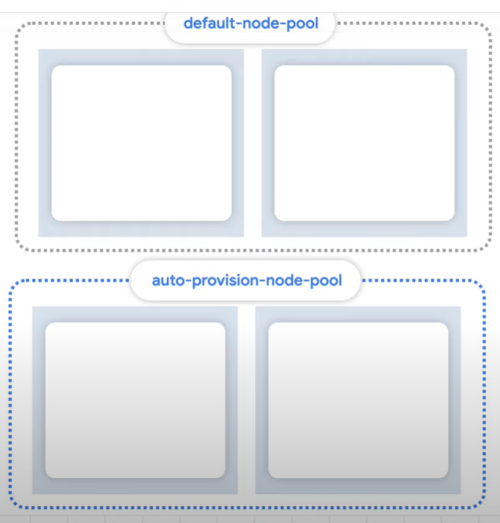 04:28
* Let's jump to another potential way to save major costs, preemptible VMs.
  + Typically when creating a machine, you can specify if you want to make it preemptible or not.
  + So preemptible means the machines cost a lot less, even up to 80% less.
    - 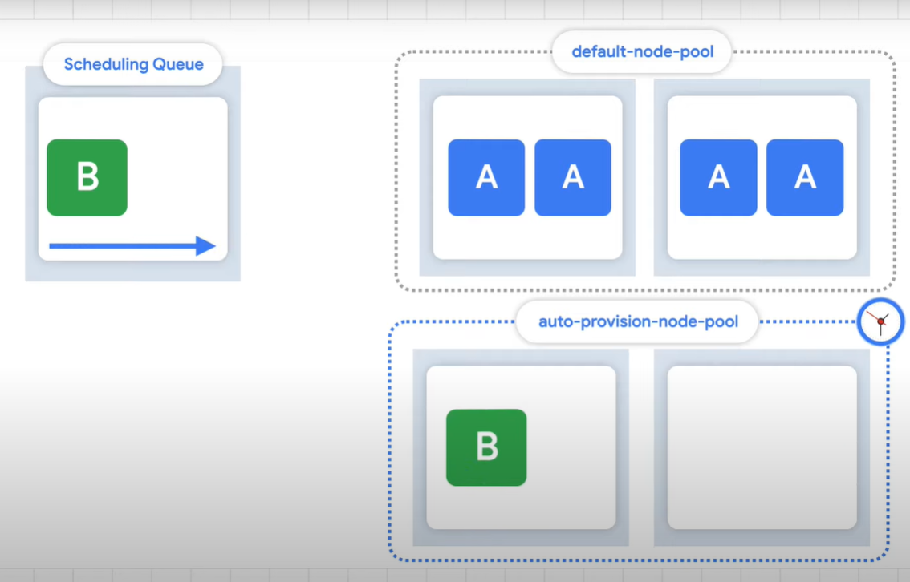
  + First of all, any instance can last a maximum of 24 hours and sometimes less.
  + They can go away with really short notice.
  + So you need to ask yourselves are my apps fault-tolerant?
  + On top of that, what happens when multiple machines go poof?
    - If there's no spare room to reschedule your app, it might take some time before Kubernetes can bring up enough machines to run your apps again.

## 5. Exploring Cost-optimization for GKE Virtual Machines - https://www.cloudskillsboost.google/focuses/15577?parent=catalog

* Overview
  + The underlying infrastructure of a Google Kubernetes Engine cluster is made up of nodes which are individual Compute VM instances. This lab shows how optimization of your cluster's infrastructure can help save costs and lead to a more efficient architecture for your applications.
  + You will learn strategy to help maximize utilization (and avoid underutilization) of your valuable infrastructure resources through selecting properly shaped machine types for an example workload. In addition to the type of infrastructure you’re using, the physical geographical location of that infrastructure also impacts cost. Through this exercise, you will explore how to create a cost effective strategy for managing higher availability regional clusters.
* What you'll do
  + Examine Resource Usage of a Deployment
  + Scale Up a Deployment
  + Migrate Your Workload to a Node Pool with an Optimized Machine Type
  + Explore Location Options for your Cluster
  + Monitor Flow Logs between Pods in Different Zones
  + Move a Chatty Pod to Minimize Cross-Zonal Traffic Costs
* Understanding Node Machine Types
  + **General Overview**
  + A machine type is a set of virtualized hardware resources available to a virtual machine (VM) instance, including the system memory size, virtual CPU (vCPU) count, and persistent disk limits. Machine types are grouped and curated by families for different workloads.
  + When choosing a machine type for your node pool, the general purpose machine type family typically offers the best price-performance ratio for a variety of workloads. The general purpose machine types consist of the N-series and E2-series:
    - 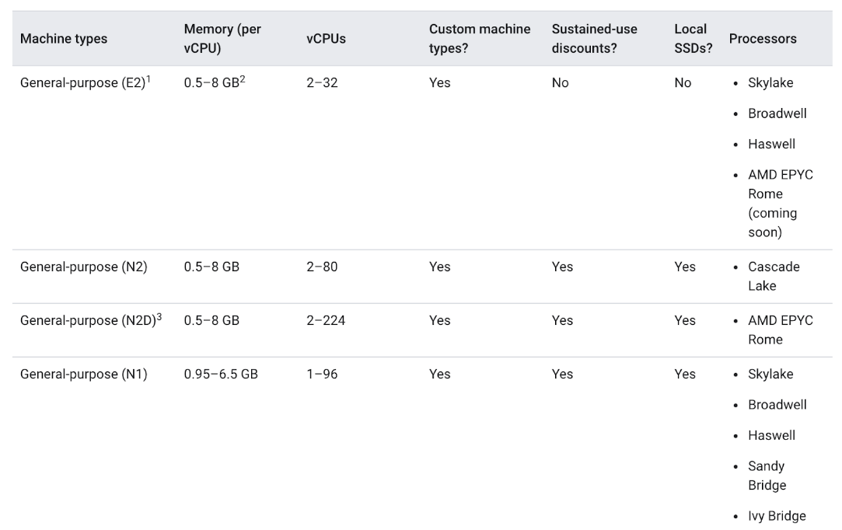
  + The differences between the machine types might help your app and they might not. In general, E2s have similar performance to N1s but are optimized for cost. Usually, utilizing the E2 machine type alone can help save on costs.
  + However, with a cluster, it's most important that the resources utilized are optimized based on your application’s needs. For bigger applications or deployments that need to scale heavily, it can be cheaper to stack your workloads on a few optimized machines rather than spreading them across many general purpose ones.
  + Understanding the details of your app is important for this decision making progress. If your app has specific requirements, you can make sure the machine type is shaped to fit the app.
  + In the following section, you will take a look at a demo app and migrate it to a node pool with a well-shaped machine type.
* Choosing the Right Machine Type for the Hello App
  + **Inspect the Hello Demo Cluster's Requirements**
    - On startup, your lab generated a **Hello Demo Cluster** with two E2 medium (2vCPU, 4GB memory) nodes. This cluster is deploying one replica of a simple web application called **Hello App**, a web server written in Go that responds to all requests with the message "Hello, World!".
    - Once your lab has finished provisioning, in the **Cloud Console**, click on your **Navigation Menu** and then click on **Kubernetes Engine**.
    - In the **Kubernetes Clusters** window, select your **hello-demo-cluster**.
    - In the following window, select the **Nodes** tab:
    - You should now see a list of your cluster's nodes:
      * 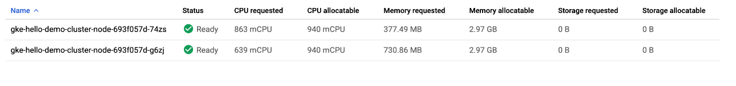
    - Observe how GKE has utilized the resources of your cluster. You can see how much cpu and memory is being requested by each node as well as how much your nodes could potentially allocate.
    - Click on the first node of your cluster.
    - Look at the **Pods** section. You should see your hello-server pod in the default namespace. If you don't see a hello-server pod, go back and select the second node of your cluster instead.
    - You'll notice the hello-server pod is requesting 400 mcpu. You should also see a handful of other kube-system pods running. These are loaded to help enable GKE's cluster services, like monitoring.
      * 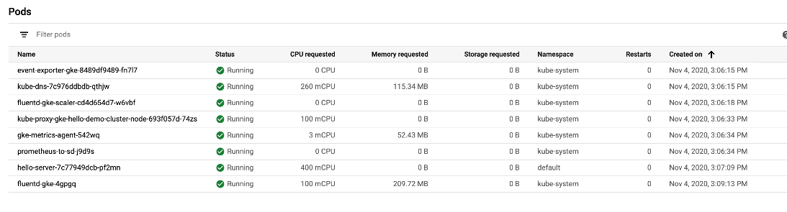
    - Press the **Back** button to return to the previous **Nodes** page.
    - Already, you'll notice that it takes two E2-medium nodes to run one replica of your Hello-App along with the essential kube-system services. Also, while you're using most of the cluster's cpu resources, you're only using about 1/3rd of its allocatable memory.
    - If the workload for this app were completely static, you could create a machine type with a custom fitted shape that has the exact amount of cpu and memory needed. By doing this, you would consequently save costs on your overall cluster infrastructure.
    - However, GKE clusters often run multiple workloads and those workloads will typically need to be scaled up and down.
    - What would happen if the Hello App were to be scaled up?
  + **Scale Up Hello App**
    - Access your cluster's credentials:
      * gcloud container clusters get-credentials hello-demo-cluster --zone us-central1-a
    - Scale up your Hello-Server:
      * kubectl scale deployment hello-server --replicas=2
    - Back in the **Console**, select **Workloads** from the **Kubernetes Engine** menu on the left:
    - You should see your hello-server with the **Does not have minimum availability** error status:
      * 
    - Click on the error message to get status details. You will see that the reason is Insufficient cpu.
    - This is to be expected. If you remember, the cluster barely had any more cpu resources and you requested another 400m with another replica of the hello-server.
    - Increase your node pool to handle your new request:
      * gcloud container clusters resize hello-demo-cluster --node-pool node --num-nodes 3 --zone us-central1-a
    - When asked to continue, type y and press enter.
    - In the **Console**, refresh the **Workloads** page until you see the status of your hello-server workload turn to **OK**:
      * 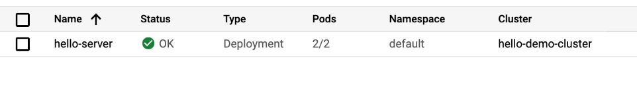
  + **Examine your Cluster**
    - With the workload successfully scaled up, navigate back to the nodes tab of your cluster.
    - Click on **hello-demo-cluster**:
      * 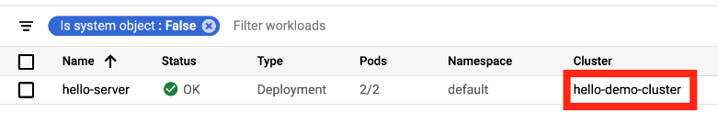
    - Then, click on the **Nodes** tab:
      * 
    - The larger node pool is able to handle the heavier workload, but look at how your infrastructure's resources are being utilized.
      * 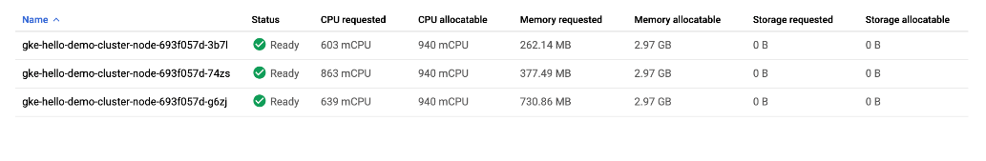
    - Although GKE uses a cluster's resources to the best of its ability, there is room for some optimization here. You can see that one of your nodes is using most of its memory, but two of your nodes have a considerable amount of unused memory.
    - At this point, if you continued to scale up the app, you would start to see a similar pattern. Kubernetes would attempt to find a node for each new replica of the hello-server deployment, fail, and then create a new node with roughly 600m of cpu.
  + **A Binpacking Problem**
    - A binpacking problem is one in which you must fit items of various volumes/shapes into a finite number of regularly shaped “bins” or containers. Essentially, the challenge is to fit the items into the fewest number of bins, “packing” them as efficiently as possible.
    - This is similar to the challenge faced when trying to optimize Kubernetes clusters for the applications they run. You have a number of applications, likely with various resource requirements (ie. memory and cpu). You must try to fit these applications into the infrastructure resources Kubernetes manages for you (where most of your cluster’s cost likely lies) as efficiently as possible.
    - Your **Hello Demo Cluster** does not employ very efficient binpacking. It would be more cost-efficient to configure Kubernetes to use a machine type more fitted to this workload.
    - **Note:**For simplicity, this lab focuses on optimizing one application. In reality, your Kubernetes cluster will likely be running many applications with varying requirements. Kubernetes has tools to help you match your application workloads to various machines Kubernetes has access to. You can use multiple GKE Node Pools to have one Kubernetes cluster manage multiple machine types.

### **Migrate to Optimized Node Pool**

* + - Create a new node pool with a larger machine type:
      * gcloud container node-pools create larger-pool --cluster=hello-demo-cluster --machine-type=e2-standard-2 --num-nodes=1 --zone=us-central1-a
    - Now, you can migrate pods to the new node pool by following these steps:
      * **Cordon the existing node pool**: This operation marks the nodes in the existing node pool (node) as unschedulable. Kubernetes stops scheduling new Pods to these nodes once you mark them as unschedulable.
      * **Drain the existing node pool**: This operation evicts the workloads running on the nodes of the existing node pool (node) gracefully.
    - First, cordon the original node pool:
      * for node in $(kubectl get nodes -l cloud.google.com/gke-nodepool=node -o=name); do kubectl cordon "$node"; done
    - Next, drain the pool:
      * for node in $(kubectl get nodes -l cloud.google.com/gke-nodepool=node -o=name); do kubectl drain --force --ignore-daemonsets --delete-local-data --grace-period=10 "$node"; done
    - At this point, you should see that your pods are running on the new, larger-pool, node pool:
      * kubectl get pods -o=wide
    - With the pods migrated, it's safe to delete the old node pool:
      * gcloud container node-pools delete node --cluster hello-demo-cluster --zone us-central1-a
    - When asked to continue, type y and enter.
    - Deletion can take about 2 minutes. Read the next section while you wait.
  + **Cost Analysis**
    - You're now running the same workload which required three e2-medium machines on one e2-standard-2 machine.
    - Take a look at the hourly cost for having an e2 standard and shared core machine types up:
    - Standard: 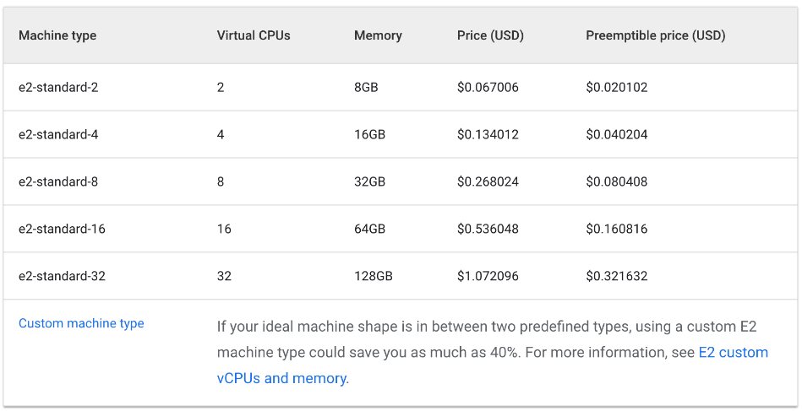
    - Shared Core: 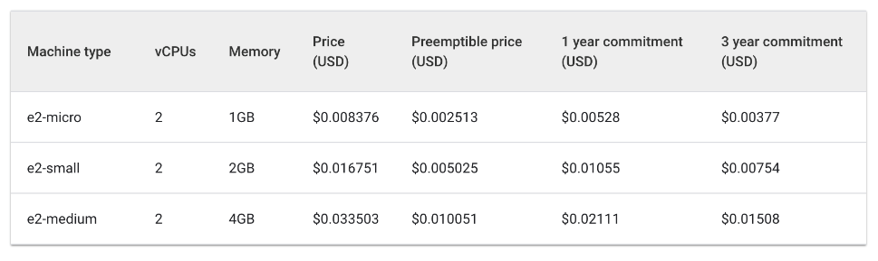
    - The cost of three e2-medium machines would be about $0.1 an hour while one e2-standard-2 is listed at about $0.067 an hour.
    - Saving $.04 an hour may seem small, but this cost can add up over the lifetime of a running application. It would be even more noticeable at a larger scale too. Because the e2-standard-2 machine can pack your workload more efficiently and there's less unused space, the cost of scaling up would grow less quickly.
    - This is interesting because E2-medium is a shared cored machine type which is designed to be cost effective for small, non resource intensive applications. But, for the Hello-App's current workload, you see that using a node pool with a larger machine type ends up being a more cost effective strategy.
    - In the **Cloud Console**, you should still be on the **Nodes** tab of your **hello-demo** cluster. Refresh this tab and examine the CPU Requested and CPU Allocatable fields for your larger-pool node.
    - Notice there's room for further optimization. The new node could fit another replica of your workload without needing to provision another node. Or again, you could potentially choose a custom sized machine type that fits the CPU and memory needs of the application saving even more resources.
    - It should be noted that these prices will vary depending on the location of your cluster. The next part of this lab will deal with selecting the best region and managing a regional cluster.
* Selecting the Appropriate Location for a Cluster
  + **Regions and Zones Overview**
    - Compute Engine resources, used for your cluster's nodes, are hosted in multiple locations worldwide. These locations are composed of regions and zones. A region is a specific geographical location where you can host your resources. Regions have three or more zones.
    - Resources that live in a zone, such as virtual machine instances or zonal persistent disks, are referred to as zonal resources. Other resources, like static external IP addresses, are regional. Regional resources can be used by any resource in that region, regardless of zone, while zonal resources can only be used by other resources in the same zone.
    - When choosing a region or zone, it's important to think about:
      * **Handling Failures** - If your resources for your app are only distributed in one zone and that zone becomes unavailable, your app will also become unavailable. For larger scale, high demand apps it's often best practice to distribute resources across multiple zones or regions in order to handle failures.
      * **Decreased Network Latency** - To decrease network latency, you might want to choose a region or zone that is close to your point of service. For example, if you mostly have customers on the East Coast of the US, then you might want to choose a primary region and zone that is close to that area.
  + **Best Practices for Clusters**
    - Costs vary between regions based on a variety of factors. For example, resources in the us-west2 region tend to be more expensive than those in us-central1.
    - When selecting a region or zone for your cluster, examine what your app is doing. For a latency-sensitive production environment, placing your app in a region/zone with decreased network latency and increased efficiency would likely give you the best performance-to-cost ratio.
    - However, a non-latency-sensitive dev environment could be placed in a less expensive region to reduce costs.
    - For more information on VMs and pricing per region, take a look at the [documentation](https://cloud.google.com/compute/vm-instance-pricing).
  + **Handling Cluster Availability**
    - The types of available clusters in GKE include zonal (single-zone or multi-zonal) and regional. At face value, a single-zone cluster will be the least expensive option. However, for high-availability of your applications, it is best to distribute your cluster’s infrastructure resources across zones.
    - For many cases, prioritizing availability in your cluster through a multi-zonal or regional cluster results in the best cost-to-performance architecture.
    - A multi-zonal cluster has at least one additional zone defined but only has a single replica of the control plane running in a single zone. Workloads can still run during an outage of the control plane's zone, but no configurations can be made to the cluster until the control plane is available.
    - A regional cluster has multiple replicas of the control plane, running in multiple zones within a given region. Nodes also run in each zone where a replica of the control plane runs. Regional clusters consume the most resources but offer the best availability.
    - Read more about cluster types [here](https://cloud.google.com/kubernetes-engine/docs/concepts/types-of-clusters).
* Managing a Regional Cluster
  + **Setup**
    - Managing your cluster's resources across multiple zones becomes a little more complex. If not careful, it's possible to accumulate extra costs from unnecessary inter-zonal communication between your pods.
    - In this section, you'll observe the network traffic of your cluster and move two chatty pods, pods which are generating a lot of traffic to one another, to be in the same zone.
    - In your **Cloud Shell** tab, create a new regional cluster (this command will take a few minutes to complete):
      * gcloud container clusters create regional-demo --region=us-central1 --num-nodes=1
    - In order to demonstrate traffic between your pods and nodes, you will create two pods on separate nodes in your regional cluster. We will use ping to generate traffic from one pod to the other to generate traffic which we can then monitor.
    - First, run this command to create a manifest for your first pod:

cat << EOF > pod-1.yaml

apiVersion: v1

kind: Pod

metadata:

name: pod-1

labels:

security: demo

spec:

containers:

- name: container-1

image: gcr.io/google-samples/hello-app:2.0

EOF

* + - Create the first pod in Kubernetes by using this command:
      * kubectl apply -f pod-1.yaml
    - Next, run this command to create a manifest for your second pod:

cat << EOF > pod-2.yaml

apiVersion: v1

kind: Pod

metadata:

name: pod-2

spec:

affinity:

podAntiAffinity:

requiredDuringSchedulingIgnoredDuringExecution:

- labelSelector:

matchExpressions:

- key: security

operator: In

values:

- demo

topologyKey: "kubernetes.io/hostname"

containers:

- name: container-2

image: gcr.io/google-samples/node-hello:1.0

EOF

* + - Create the second pod in Kubernetes:
      * kubectl apply -f pod-2.yaml
    - The pods you created use the node-hello container and output a Hello Kubernetes message when requested.
    - If you look back at the pod-2.yaml file you created, you can see that **Pod Anti Affinity** is a defined rule. This enables you to ensure that the pod is not scheduled on the same node as pod-1. This is done by matching an expression based on pod-1’s security: demo label. **Pod Affinity** is used to ensure pods are scheduled on the same node, while **Pod Anti Affinity** is used to ensure pods are not scheduled on the same node.
    - Kubernetes also has a concept of [Node Affinity](https://kubernetes.io/docs/tasks/configure-pod-container/assign-pods-nodes-using-node-affinity/), which can help you optimize which applications are run on what machine types.
    - In this case, **Pod Anti Affinity** is being used to help illustrate traffic between nodes, but smart use of **Pod Anti Affinity** and **Pod Affinity** can help you utilize your regional cluster's resources even better.
    - View the pods you created:
      * kubectl get pod pod-1 pod-2 --output wide
    - Take note of the IP address of pod-2. You will use it in the following command.
  + **Simulate Traffic**
    - Get a shell to your pod-1 container:
      * kubectl exec -it pod-1 -- sh
    - In your shell, send a request to pod-2 replacing **[POD-2-IP]** with the internal IP displayed for pod-2:
      * ping [POD-2-IP]:8080
    - Take note of the average latency it takes to ping pod-2 from pod-1.
  + **Examine Flow Logs**
    - With pod-1 pinging pod-2, you can enable flow logs on the subnet of the VPC the cluster was created to observe traffic.
    - In the **Cloud Console**, open the **Navigation Menu** and click **VPC Network** in the **Networking** section.
    - Locate the default subnet in the us-central1 region and click on it.
      * 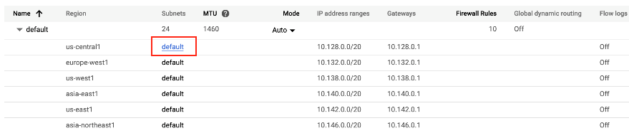
    - Click **Edit** at the top of the screen.
    - Toggle **Flow Logs** to be **On**. Then, click **Save**.
      * 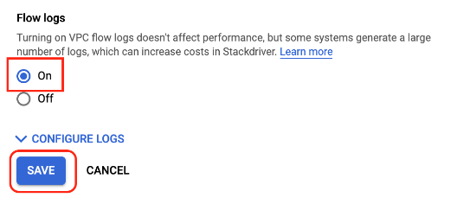
    - Next, click **View Flow Logs**.
      * 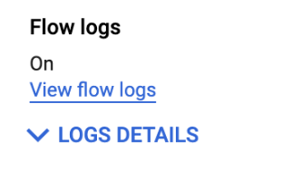
    - You'll now see a list of logs that display a large amount of information any time something was sent or received from one of your instances.
      * 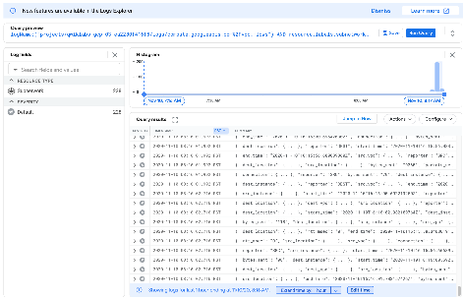
    - If the logs are not generated then replace / before vpc_flows with %2F as given in the above screenshot
    - This can be a little difficult to read. Next, export it to a BigQuery table so you can query the relevant information.
    - Click on **More actions** > **Create Sink**.
      * 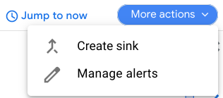
    - Name your sink FlowLogsSample.
      * 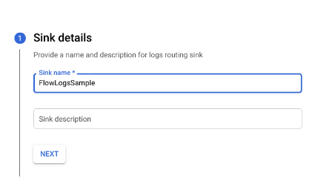
    - Click **Next**.
  + **Sink Destination**
    - For your **Sink Service**, select **BigQuery Dataset**.
    - For your **BigQuery Dataset**, select **Create new BigQuery dataset**.
    - Name your dataset us_central_flow_logs, and click **CREATE DATASET**.
    - Everything else can be left as-is.
      * 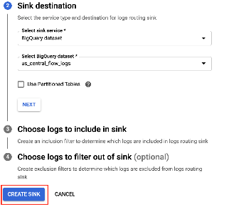
    - Click **Create Sink**.
    - Now, inspect your newly created dataset.
    - In the **Cloud Console**, from the **Navigation Menu** in the **Big Data** section, click **BigQuery**.
    - Click **Done**.
    - Select your project name, and then select the us_central_flow_logs to see newly created table. If no table is there, you may need to refresh until it has been created.
    - Click on the compute_googleapis_com_vpc_flows_xxx table under your us_central_flow_logs dataset.
      * 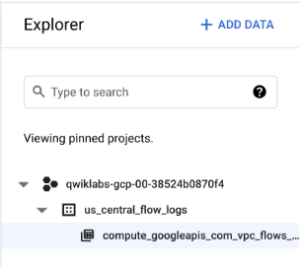
    - Click on **Query > In new tab**.
      * 
    - In the BigQuery Editor, paste this in between SELECT and FROM:
      * jsonPayload.src_instance.zone AS src_zone, jsonPayload.src_instance.vm_name AS src_vm, jsonPayload.dest_instance.zone AS dest_zone, jsonPayload.dest_instance.vm_name
    - Click **Run**.
      * 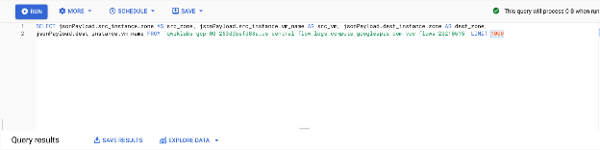
    - You'll see the flow logs from before but filtered by source zone, source vm, destination zone, and destination vm.
    - Locate a few rows where there are calls being made between two different zones in your regional-demo cluster.
      * 
    - Your logs will not be exactly the same numerically as the example image.
    - Observing the flow logs, you can see that there is frequent traffic between different zones.
    - Next, you will move the pods into the same zone and observe the benefits.
  + **Move a Chatty Pod to Minimize Cross-Zonal Traffic Costs**
    - Back in **Cloud Shell**, press **Ctrl** + **C** to cancel the ping command.
    - Type the exit command to exit pod-1's shell:
      * exit
    - Run this command to edit the pod-2 manifest:
      * sed -i 's/podAntiAffinity/podAffinity/g' pod-2.yaml
    - This changes your Pod Anti Affinity rule into a Pod Affinity rule while still using the same logic. Now pod-2 will be scheduled on the same node as pod-1.
    - Delete the current running pod-2:
      * kubectl delete pod pod-2
    - With pod-2 deleted, recreate it using the newly edited manifest:
      * kubectl create -f pod-2.yaml
    - View the pods you created and ensure they are both Running:
    - K ubectl get pod pod-1 pod-2 --output wide
    - From the output, you can see that Pod-1 and Pod-2 are now running on the same node.
    - Take note of the IP address of pod-2. You will use it in the following command.
    - Get a shell to your pod-1 container:
      * kubectl exec -it pod-1 -- sh
    - In your shell, send a request to pod-2 replacing **[POD-2-IP]** with the internal IP for pod-2 from the earlier command:
      * ping [POD-2-IP]:8080
    - You'll notice the average ping time between these pods is much faster now.
    - At this point, you can go back to your flow logs BigQuery dataset and check recent logs to verify there are no more undesired inter-zonal communications.
  + **Cost Analysis**
    - Take a look at the **VM-VM egress pricing within Google Cloud**:
    - 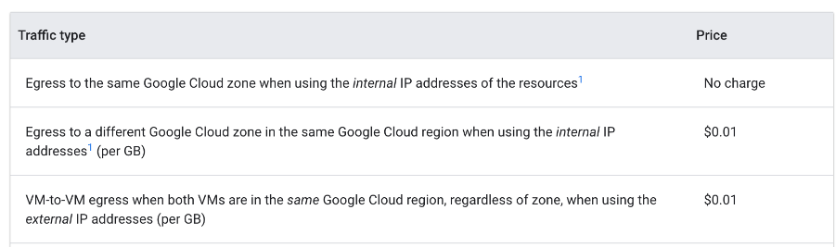
    - When the pods were pinging each other from different zones, it was costing $0.01 per GB. While that may seem small, it could add up very quickly in a large scale cluster with multiple services making frequent calls between zones.
    - When you moved the pods into the same zone, the pinging became free of charge.

## 6. Autoscaling with GKE: Overview and pods - https://youtu.be/7naCIxIaV1M

* + 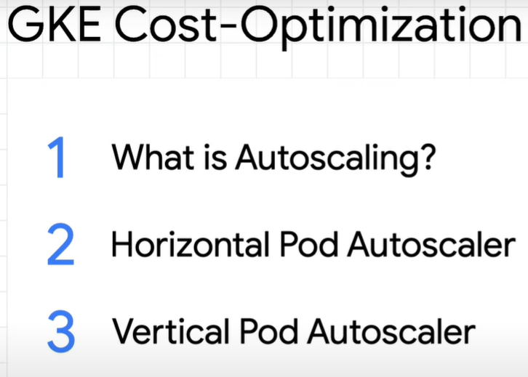
* autoscaling is really all about two things, getting additional resources when demand increases and shutting down or removing resources when demand decreases.
* By setting autoscaling up efficiently and specific to your workload, you'll be able to minimize waste and cost.
  + 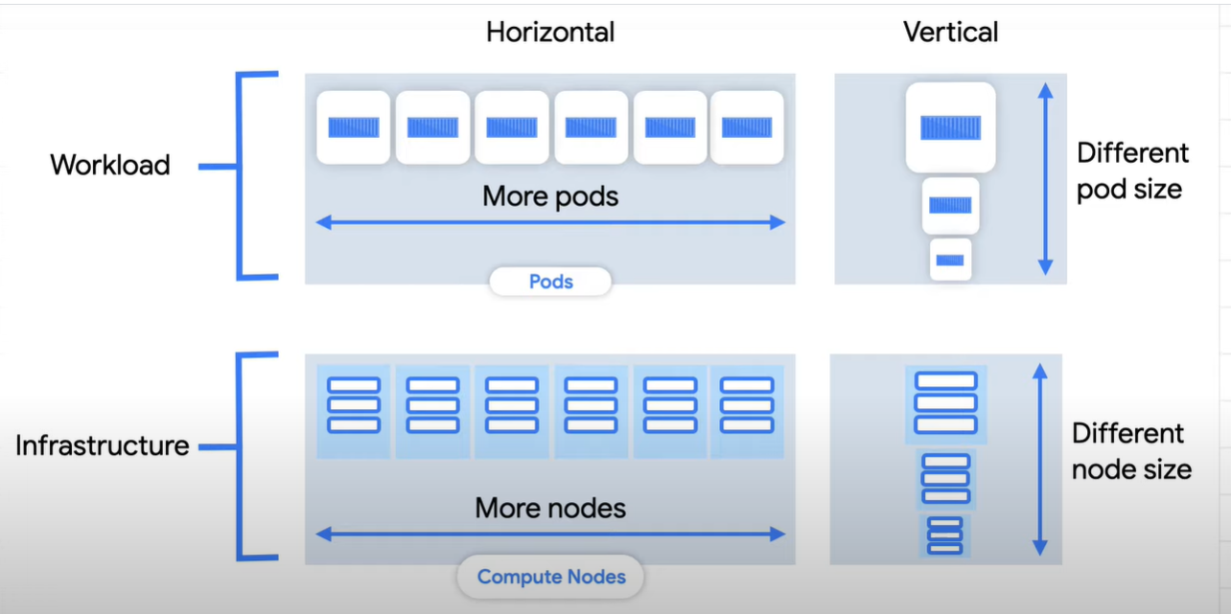
* Workloads are made up of pods, which are running containerized applications.
* Infrastructure is made up of nodes, which are responsible for the actual resources, like computing capacity and memory.
  + Horizontal scaling is done by adding more pods or nodes. If there's a lot of demand coming in, the autoscaler can try to increase the number of pods or nodes to handle it.
  + Vertical scaling is done by making pods or nodes bigger. When demand increases, a larger pod or node may be able to reduce the burden by handling more.
* GKE handles autoscaling.
  + 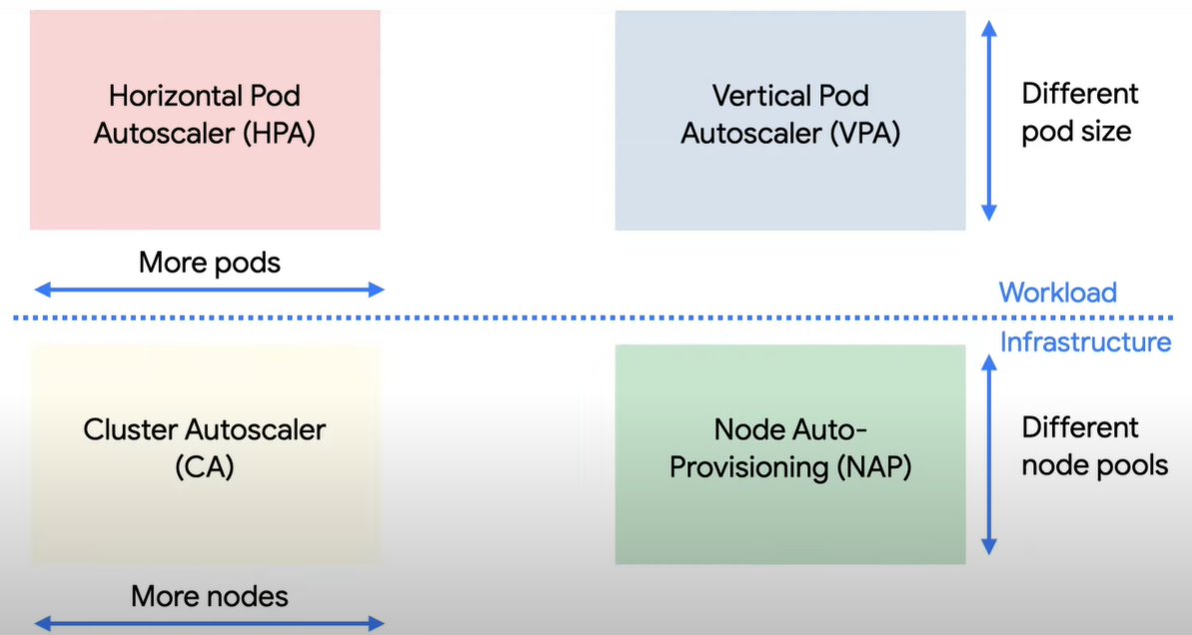
  + For horizontal scaling, you'll need a metric that represents the demand on your workload, such as CPU utilization or requests per second.
  + With that target, the horizontal pod autoscaler can try to add pods to get your workload back to your desired state.
    - Adding pods should mean that the work is spread out evenly, and a metric like average CPU utilization would go down across your pods.
    - Similarly, if there's not much demand, the autoscaler can remove pods, which is great for saving on costs.
    - When using a horizontal pod autoscaler, remember that there might be a lag time depending on how long it takes your container to start up.
    - Setting the correct amount of available metric space, or buffer, requires knowing how well you can handle spikes in demand.
    - if the buffer is too small and the pods take a long time to spin up, your app might get overloaded.
    - On the other hand, too large of a buffer can lead to wasted resources and extra costs.
    - 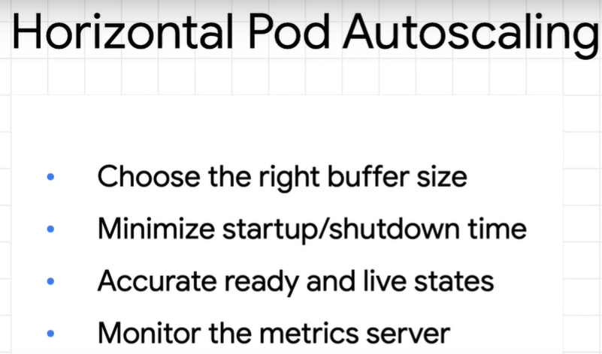
  + Now, let's look at vertical pod autoscaling.
    - Rather than adding additional pod replicas, here, the pods actually get recreated with more or less resources, depending on CPU and memory usage.
    - It has three modes-- off, initial, and auto.
      * When it's off, no autoscaling actually happens, but the autoscaler is looking at your pods and creating recommendations based on usage that you can inspect, which also happens in the other two modes.
      * If it's set to initial, those recommendations will be used to create resized pods as they're needed. After creating a pod at the recommended size, based on those recommendations, it won't change the pod size afterward.
      * If the autoscaler is set to auto, those recommendations will be used to regularly resize pods by deleting them and recreating them with the adjusted amounts.
    - 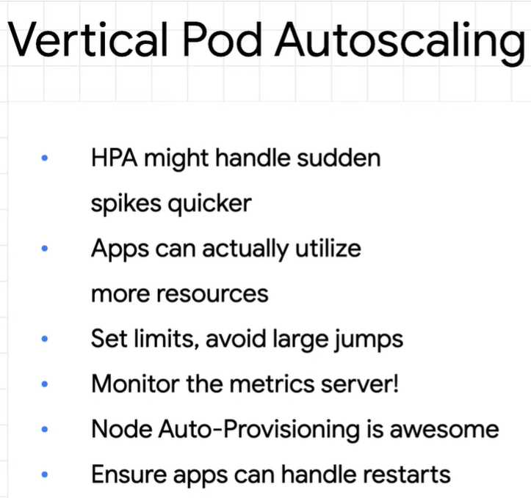

## 7. Autoscaling with GKE: Clusters and nodes

* + 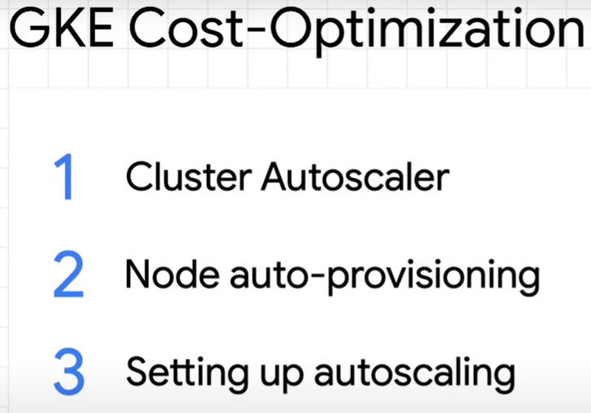
* what can you do with the infrastructure side? just like the pod autoscalers, you can think of the same horizontal and vertical options for infrastructure.
* This time, we're talking about changing the number of nodes or automatically creating additional node pools with optimized size.
* The cluster autoscaler is designed to add or remove nodes based on demand.
* If additional pods aren't able to be put into the existing nodes that are running, the cluster autoscaler will create a new node, so that the pods can get placed.
* the cluster autoscaler is perfect for cost optimization since it is actually built to prefer lower costs.
  + 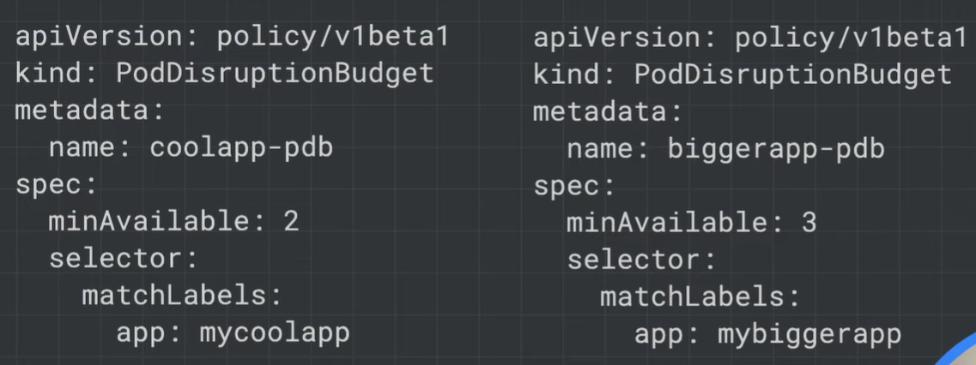
* Just like the pod autoscaler, having an appropriate pod disruption budget is important for having an effective cluster autoscaler. The budget defines the minimum number of running pods for your workload.
* there are some pods that can't be restarted by default, which will then block the cluster autoscaler from removing a node. System pods, like Kube-DNS and pods that use local storage.
  + For system pods, you can set a pod disruption budget, which will allow them to be rescheduled on another node, freeing up their original node to be deleted.
  + But you may not want to set a budget for some system pods that only have one replica, like metric server, since restarting them can cause temporary disruptions.
  + 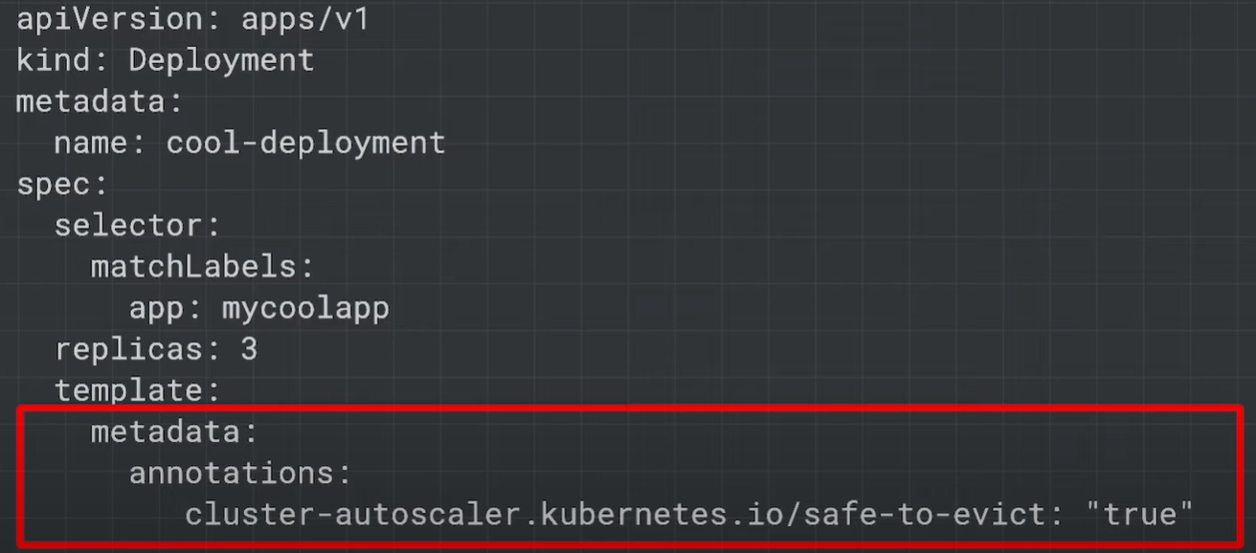
  + For pods with local storage, you can enable a special annotation called safe to evict to let the cluster autoscaler know that they're safe to be restarted.
  + If you have any pods that are supposed to run for a long time without being restarted, you might want to move those over to a separate node pool, so they don't block the cluster autoscaler.
  + 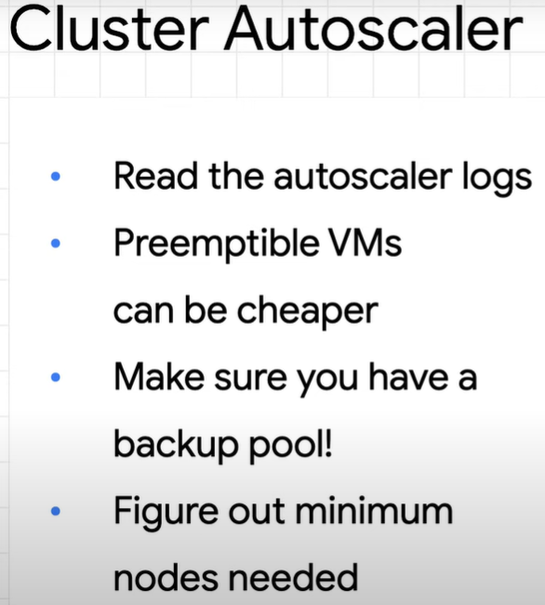
* However, GKE specifically has another feature to scale vertically called node autoprovisioning.
  + Node autoprovisioning actually adds new node pools that are sized to meet demand.
  + Without node autoprovisioning, the cluster autoscaler will only be able to create new nodes in the node pools that you've specified.
  + 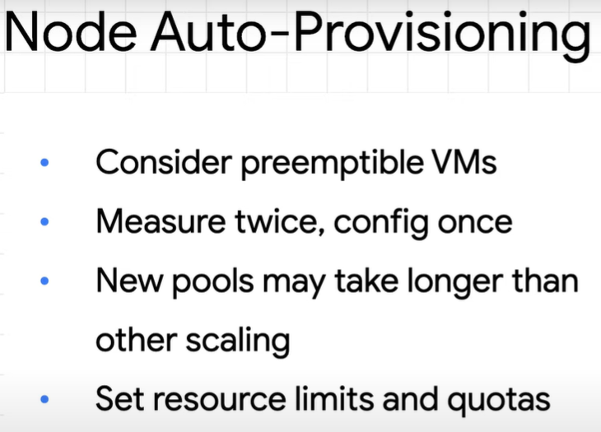

## 8. Understanding and Combining GKE Autoscaling Strategies - https://www.cloudskillsboost.google/focuses/15636?parent=catalog

* Overview
  + Google Kubernetes Engine has horizontal and vertical solutions for automatically scaling your pods as well as your infrastructure. When it comes to cost-optimization, these tools become extremely useful in ensuring that your workloads are being run as efficiently as possible and that you're only paying for what you're using.
  + In this lab will set up and observe **Horizontal Pod Autoscaling** and **Vertical Pod Autoscaling** for pod-level scaling and **Cluster Autoscaler** (horizontal infrastructure solution) and **Node Auto Provisioning** (vertical infrastructure solution) for node-level scaling. First you'll use these autoscaling tools to save as many resources as possible and shrink your cluster's size during a period of low demand. Then you will increase the demands of your cluster and observe how autoscaling maintains availability.
* **What You'll Do**
  + Decrease number of replicas for a Deployment with **Horizontal Pod Autoscaler**
  + Decrease CPU request of a Deployment with **Vertical Pod Autoscaler**
  + Decrease number of nodes used in cluster with **Cluster Autoscaler**
  + Automatically create an optimized node pool for workload with **Node Auto Provisioning**
  + Test the autoscaling behavior against a spike in demand
  + Overprovision your cluster with **Pause Pods**
* **Provision testing environment**
  + Set your default zone to us-central1-a:
    - gcloud config set compute/zone us-central1-a
  + Run the following command to create a three node cluster in the us-central1-a zone:
    - gcloud container clusters create scaling-demo --num-nodes=3 --enable-vertical-pod-autoscaling
  + To help demonstrate horizontal pod autoscaling, this lab uses a custom docker image based on the php-apache image. It defines an index.php page which performs some CPU intensive computations. You will monitor a deployment of this image.
  + Create a manifest for the php-apache deployment:

cat << EOF > php-apache.yaml

apiVersion: apps/v1

kind: Deployment

metadata:

name: php-apache

spec:

selector:

matchLabels:

run: php-apache

replicas: 3

template:

metadata:

labels:

run: php-apache

spec:

containers:

- name: php-apache

image: k8s.gcr.io/hpa-example

ports:

- containerPort: 80

resources:

limits:

cpu: 500m

requests:

cpu: 200m

---

apiVersion: v1

kind: Service

metadata:

name: php-apache

labels:

run: php-apache

spec:

ports:

- port: 80

selector:

run: php-apache

EOF

* + Apply the newly created manifest to your cluster:
    - kubectl apply -f php-apache.yaml
* Scale pods with Horizontal Pod Autoscaling
  + Horizontal Pod Autoscaling changes the shape of your Kubernetes workload by automatically increasing or decreasing the number of pods in response to the workload's CPU or memory consumption, or in response to custom metrics reported from within Kubernetes or external metrics from sources outside of your cluster.
  + In Cloud Shell, run this command to inspect your cluster's deployments:
    - kubectl get deployment
  + You should see the php-apache deployment with 3/3 pods running:
    - 
  + If you don't see 3 available pods, wait a minute for the pods to be created and try the previous command again. If you see 1/1 available pods, then it's likely enough time has passed for your deployment to scale down.
  + Apply horizontal autoscaling to the php-apache deployment:
    - kubectl autoscale deployment php-apache --cpu-percent=50 --min=1 --max=10
  + This autoscale command will configure a Horizontal Pod Autoscaler that will maintain between 1 and 10 replicas of the pods controlled by the php-apache deployment. The cpu-percent flag specifies 50% as the target average CPU utilization of requested CPU over all the pods. HPA will adjust the number of replicas (via the deployment) to maintain an average CPU utilization of 50% across all pods.
  + Check the current status of your Horizontal Pod Autoscaler:
    - kubectl get hpa
  + Under the **Targets** column you should see **0%/50%**.
  + This means that the pods within your deployment are currently at 0% of their target average CPU utilization. This is to be expected as the php-apache app is receiving no traffic right now.
  + If you see **<unknown>/50%**, wait a minute and run the kubectl get hpa command again. Your HPA hasn't created an assessment yet.
  + Also, take note of the **Replicas** column. To start with, the value will be **3**. This number will be changed by the autoscaler as the number of required pods changes.
  + In this case, the autoscaler will scale the deployment down to the minimum number of pods indicated when you run the autoscale command. Horizontal Pod Autoscaling takes 5-10 minutes and will require shutting down or starting new pods depending on which way it's scaling.
  + Continue to the next step of the lab. You will inspect the results of the autoscaler later on.
  + While you use cpu-percent as the target metric for your autoscaler in this lab, HPA allows custom metrics to be defined so that you can scale your pods based on other useful metrics captured in the logs.
* Scale size of pods with Vertical Pod Autoscaling
  + Vertical Pod Autoscaling frees you from having to think about what values to specify for a container's CPU and memory requests. The autoscaler can recommend values for CPU and memory requests and limits, or it can automatically update the values.
  + Vertical Pod Autoscaling should not be used alongside Horizontal Pod Autoscaling on CPU or memory. Both autoscalers will try to respond to changes in demand on the same metrics and conflict. However, VPA on CPU or memory can be used with HPA on custom metrics to avoid overlap.
  + Vertical Pod Autoscaling has already been enabled on the scaling-demo cluster. To verify run:
    - gcloud container clusters describe scaling-demo | grep ^verticalPodAutoscaling -A 1
  + The output should read enabled: true
  + Vertical Pod Autoscaling can be enabled on an existing cluster with gcloud container clusters update scaling-demo --enable-vertical-pod-autoscaling
  + To demonstrate VPA, you will deploy the hello-server app.
  + Apply the hello-server deployment to your cluster:
    - kubectl create deployment hello-server --image=gcr.io/google-samples/hello-app:1.0
  + Ensure the deployment was successfully created:
    - kubectl get deployment hello-server
  + Assign a CPU resource request of 450m to the deployment:
    - kubectl set resources deployment hello-server --requests=cpu=450m
  + Next, run this command to inspect the container specifics of the hello-server pods:
    - kubectl describe pod hello-server | sed -n "/Containers:$/,/Conditions:/p"
  + In the output, find **Requests**. Note that this pod is currently requesting the 450m CPU you assigned.
  + Now, create a manifest for you **Vertical Pod Autoscaler**:

cat << EOF > hello-vpa.yaml

apiVersion: autoscaling.k8s.io/v1

kind: VerticalPodAutoscaler

metadata:

name: hello-server-vpa

spec:

targetRef:

apiVersion: "apps/v1"

kind: Deployment

name: hello-server

updatePolicy:

updateMode: "Off"

EOF

* + The above generates a manifest for a Vertical Pod Autoscaler targeting the hello-server deployment with an Update Policy of **Off**. A VPA can have one of three different update policies which can be useful depending on your application:
    - **Off:** this policy means VPA will generate recommendations based on historical data which you can manually apply.
    - **Initial**: VPA recommendations will be used to create new pods once and then won't change the pod size after.
    - **Auto:** pods will regularly be deleted and recreated to match the size of the recommendations.
  + Apply the manifest for hello-vpa:
    - kubectl apply -f hello-vpa.yaml
  + Wait a minute, and then view the VerticalPodAutoscaler:
    - kubectl describe vpa hello-server-vpa
  + Locate the "Container Recommendations" at the end of the output. If you don't see it, wait a little longer and try the previous command again. When it appears, you'll see several different recommendation types, each with values for CPU and memory:
    - **Lower Bound**: this is the lower bound number VPA looks at for triggering a resize. If your pod utilization goes below this, VPA will delete the pod and scale it down.
    - **Target:** this is the value VPA will use when resizing the pod.
    - **Uncapped Target**: if no minimum or maximum capacity is assigned to the VPA, this will be the target utilization for VPA.
    - **Upper Bound**: this is the upper bound number VPA looks at for triggering a resize. If your pod utilization goes above this, VPA will delete the pod and scale it up.
  + You'll notice VPA is recommending the CPU request for this container be set to **25m** instead of the previous **100m** as well as giving you a suggested number for how much memory should be requested. At this point, these recommendations can be manually applied to the hello-server deployment.
  + Vertical Pod Autoscaling bases its recommendations on historical data from the container. In practice, it's recommended to wait at least 24 hours to collect recommendation data before applying any changes.
  + In order to observe VPA and its effects within this lab, you will change the **hello-vpa** update policy to **Auto** and observe the scaling.
  + Update the manifest to set the policy to **Auto** and apply the configuration:
    - sed -i 's/Off/Auto/g' hello-vpa.yaml
    - kubectl apply -f hello-vpa.yaml
  + In order to resize a pod, Vertical Pod Autoscaler will need to delete that pod and recreate it with the new size. By default, to avoid downtime, VPA will not delete and resize the last active pod. Because of this, you will need at least 2 replicas to see VPA make any changes.
  + Scale hello-server deployment to 2 replicas:
    - kubectl scale deployment hello-server --replicas=2
  + Now, watch your pods:
    - kubectl get pods -w
  + Wait until you see your hello-server-xxx pods in the **terminating** status (or navigate to **Kubernetes Engine** > **Workloads**):
    - 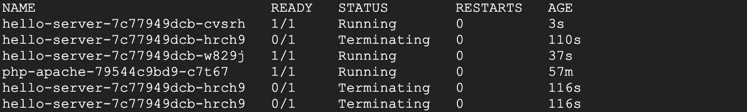
  + This is a sign that your VPA is deleting and resizing your pods. Once you see this, press **Ctrl** + **c** to quit the command.
* HPA results
  + By this point, your **Horizontal Pod Autoscaler** will have most likely scaled your php-apache deployment down.
  + Run this command to check your HPA:
    - kubectl get hpa
  + Look at the **Replicas** column. You'll see that your php-apache deployment has been scaled down to 1 pod.
  + If you still see 3 replicas for your php-apache deployment, you need to wait a few more minutes for the autoscaler to take action.
  + The HPA takes advantage of the fact that the app is inactive right now and removes all the unused resources. Furthermore, if more demand were placed on the php-apache app, it would scale back up to account for the load.
  + If availability of your application is a main concern, it's considered best practice to leave a slightly higher buffer as the minimum pod number for your Horizontal Pod Autoscaler to account for the time it takes to scale.
  + This is extremely useful when thinking about cost optimization. A well-tuned autoscaler means that you are maintaining high availability of your application while only paying for the resources that are required to maintain that availability, regardless of the demand.
* VPA results
  + Now, the VPA should have resized your pods in the hello-server deployment. Inspect your pods:
    - kubectl describe pod hello-server | sed -n "/Containers:$/,/Conditions:/p"
  + Find the **Requests:** field. Your **Vertical Pod Autoscaler** recreated the pods with their target utilizations. Now it should be requesting a lower amount of CPU and also be requesting a certain amount of memory:
    - 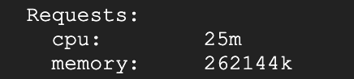
  + If you still see a CPU request of 450m for either of the pods, manually set your CPU resource to the target with this command:
  + kubectl set resources deployment hello-server --requests=cpu=25m
  + Sometimes VPA in auto mode may take a long time or set inaccurate upper or lower bound values without the time to collect accurate data. In order to not lose time in the lab, using the recommendation as if it were in "Off" mode is a simple solution.
  + In this case, VPA becomes an excellent tool for optimizing resource utilization and, in effect, saving on costs. The original request of 400m of CPU was higher than what this container needed. By adjusting the request to the recommended 25m, you're able to use less CPU from the node pool, potentially to the point of requiring less nodes to be provisioned in the cluster.
  + With the Auto update policy, your VPA would continue to delete and resize the pods of the hello-server deployment throughout its lifetime. It could scale pods up with larger requests to handle heavy traffic and then scale back down during a downtime. This can be great for accounting for steady increases of demand for your application, but it does risk losing availability during heavy spikes.
  + Depending on your application, it's generally safest to use VPA with the **Off** update policy and take the recommendations as needed in order to both optimize resource usage and maximize your cluster's availability.
  + In the next sections, you will look at how to further optimize your resource utilization with the Cluster Autoscaler and Node Auto Provisioning.
* Cluster autoscaler
  + The **Cluster Autoscaler** is designed to add or remove nodes based on demand. When demand is high, cluster autoscaler will add nodes to the node pool to accommodate that demand. When demand is low, cluster autoscaler will scale your cluster back down by removing nodes. This allows you to maintain high availability of your cluster while minimizing superfluous costs associated with additional machines.
  + Enable autoscaling for your cluster:
    - gcloud beta container clusters update scaling-demo --enable-autoscaling --min-nodes 1 --max-nodes 5
  + This will take a few minutes to complete.
  + When scaling a cluster, the decision of when to remove a node is a trade-off between optimizing for utilization or the availability of resources. Removing underutilized nodes improves cluster utilization, but new workloads might have to wait for resources to be provisioned again before they can run.
  + You can specify which autoscaling profile to use when making such decisions. The currently available profiles are:
    - **Balanced**: The default profile.
    - **Optimize-utilization**: Prioritize optimizing utilization over keeping spare resources in the cluster. When selected, the cluster autoscaler scales down the cluster more aggressively. It can remove more nodes, and remove nodes faster. This profile has been optimized for use with batch workloads that are not sensitive to start-up latency.
  + Switch to the optimize-utilization autoscaling profile so that the full effects of scaling can be observed:
    - gcloud beta container clusters update scaling-demo --autoscaling-profile optimize-utilization
  + With autoscaling enabled, observe your cluster in the Cloud Console. **Navigation > Kubernetes Engine** > **Clusters**.
  + On the **Clusters** page, select the **scaling-demo** cluster.
  + In the scaling-demo's cluster page, select the **Nodes** tab:
  + Take a look at the overview of your three nodes' resource utilization.
    - 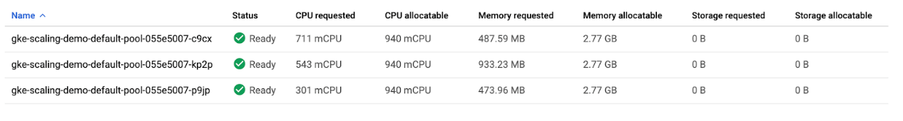
  + Your numbers may be different from the ones pictured. Kubernetes does not provision and assign resources in the same way every time.
  + If you combine the values of **CPU requested** and **CPU allocatable** for the 3 nodes, the totals would be 1555m and 2820m, respectively. This means that there's a total of 1265m CPU available across the entire cluster. This is greater than what could be provided by one node.
  + To optimize utilization, the current workload at its current demand could be consolidated into two nodes instead of three. However, your cluster hasn't automatically scaled down yet. This is because of the system pods distributed across the cluster.
  + Your cluster runs a number of deployments under the kube-system namespace which allow the different GKE services like logging, monitoring, autoscaling, etc. to work. This can be verified by running this command in Cloud Shell:
    - kubectl get deployment -n kube-system
  + By default, most of the system pods from these deployments will prevent cluster autoscaler from taking them completely offline to reschedule them. Generally, this is desired because many of these pods collect data used in other deployments and services. For example, metrics-agent being temporarily down would cause a gap in data collected for VPA and HPA, or the fluentd pod being down could create a gap in your cloud logs.
  + For the purpose of this lab, you will apply Pod Disruption Budgets to your kube-system pods which will allow cluster autoscaler to safely reschedule them on another node. This will give enough room to scale your cluster down.
* **Pod Disruption Budgets (PDB)** define how Kubernetes should handle disruptions like upgrades, pod removals, running out of resources, etc. In PDBs, you can specify the max-unavailable and/or the min-available number of pods a deployment should have.
  + Run these commands to create the Pod Disruption Budgets for each of your kube-system pods:
    - kubectl create poddisruptionbudget kube-dns-pdb --namespace=kube-system --selector k8s-app=kube-dns --max-unavailable 1
    - kubectl create poddisruptionbudget prometheus-pdb --namespace=kube-system --selector k8s-app=prometheus-to-sd --max-unavailable 1
    - kubectl create poddisruptionbudget kube-proxy-pdb --namespace=kube-system --selector component=kube-proxy --max-unavailable 1
    - kubectl create poddisruptionbudget metrics-agent-pdb --namespace=kube-system --selector k8s-app=gke-metrics-agent --max-unavailable 1
    - kubectl create poddisruptionbudget metrics-server-pdb --namespace=kube-system --selector k8s-app=metrics-server --max-unavailable 1
    - kubectl create poddisruptionbudget fluentd-pdb --namespace=kube-system --selector k8s-app=fluentd-gke --max-unavailable 1
    - kubectl create poddisruptionbudget backend-pdb --namespace=kube-system --selector k8s-app=glbc --max-unavailable 1
    - kubectl create poddisruptionbudget kube-dns-autoscaler-pdb --namespace=kube-system --selector k8s-app=kube-dns-autoscaler --max-unavailable 1
    - kubectl create poddisruptionbudget stackdriver-pdb --namespace=kube-system --selector app=stackdriver-metadata-agent --max-unavailable 1
    - kubectl create poddisruptionbudget event-pdb --namespace=kube-system --selector k8s-app=event-exporter --max-unavailable 1
  + In each of these commands, you are selecting a different **kube-system** deployment pod based off a label defined in its creation and specifying that there can be 1 unavailable pod for each of these deployments. This will allow the autoscaler to reschedule the system pods.
  + With the PDBs in place, your cluster should scale down from three nodes to two nodes in a minute or two.
  + Rerun this command in Cloud Shell until you see only two nodes total:
    - kubectl get nodes
  + In the Cloud Console, refresh the **Nodes** tab of your **scaling-demo** or return there with this [link](https://console.cloud.google.com/kubernetes/clusters/details/us-central1-a/scaling-demo/nodes) to inspect how your resources were packed:
    - 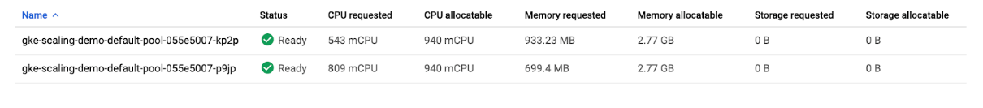
  + You set up automation that scaled your cluster down from three nodes to two nodes!
  + Thinking about the costs, as a result of scaling down your nodepool, you will be billed for less machines during periods of low demand on your cluster. This scaling could be even more dramatic if you were fluctuating from high demand to low demand periods during the day.
  + It’s important to note that, while **Cluster Autoscaler** removed an unnecessary node, **Vertical Pod Autoscaling** and **Horizontal Pod Autoscaling** helped reduce enough CPU demand so that the node was no longer needed. Combining these tools is a great way to optimize your overall costs and resource usage.
  + So, the cluster autoscaler helps add and remove nodes in response to pods needing to be scheduled. However, GKE specifically has another feature to scale vertically, called **node auto-provisioning**.
* Node Auto Provisioning
  + **Node Auto Provisioning** (NAP) actually adds new node pools that are sized to meet demand. Without node auto provisioning, the cluster autoscaler will only be creating new nodes in the node pools you've specified, meaning the new nodes will be the same machine type as the other nodes in that pool. This is perfect for helping optimize resource usage for batch workloads and other apps that don't need extreme scaling, since creating a node pool that is specifically optimized for your use case might take more time than just adding more nodes to an existing pool.
  + Enable Node Auto Provisioning:
    - gcloud container clusters update scaling-demo --enable-autoprovisioning --min-cpu 1 --min-memory 2 --max-cpu 45 --max-memory 160
  + In the command, you specify a minimum and maximum number for your CPU and memory resources. This is for the entire cluster.
  + **NAP** can take a little bit of time and it's also highly likely it won't create a new node pool for the **scaling-demo** cluster at its current state.
  + In the next sections, you will increase the demand to your cluster and observe the actions of your autoscalers as well as **NAP**.
* Test with Larger Demand
  + So far, you've analyzed how HPA, VPA, and cluster autoscaler can help save resources and costs while your application has low demand. Now, you'll look at how these tools handle availability for increased demand.
  + Open a new tab in **Cloud Shell** by pressing the **+** icon:
  + In the new tab, run this command to send an infinite loop of queries to the php-apache service:
    - kubectl run -i --tty load-generator --rm --image=busybox --restart=Never -- /bin/sh -c "while sleep 0.01; do wget -q -O- http://php-apache; done"
  + Return to your original **Cloud Shell** tab.
  + Within a minute or so, you should see the higher CPU load on your HPA by executing:
    - kubectl get hpa
  + Wait and rerun the command until you see your target above 100%.
    - 
  + Now, monitor how your cluster handles the increased load by periodically running this command:
    - kubectl get deployment php-apache
  + You can also monitor your cluster by refreshing the **nodes** tab in your Cloud Console
  + After a few minutes, you will see a few things happen.
    - First, your php-apache deployment will automatically be scaled up by HPA to handle the increased load.
    - Then, **cluster autoscaler** will need to provision new nodes to handle the increased demand.
    - Finally, **node auto provisioning** will create a node pool optimized for the CPU and memory requests of your cluster’s workloads. In this case, it should be a high cpu, low memory node pool because the load test is pushing the cpu limits.
  + Wait until your php-apache deployment is scaled up to 7 replicas and your nodes tab looks similar to this:
    - 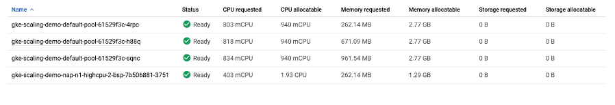
  + Return to the **Cloud Shell** tab you ran the load test in and cancel it by pressing **Ctrl** + **c**. Your cluster will now eventually scale back down as the demand decreases again.
  + Your cluster efficiently scaled up to meet a higher demand! However, take note of the amount of time it took to handle this spike in demand. For many applications, losing availability while provisioning new resources can be an issue.
* Optimize larger loads
  + When scaling up for larger loads, horizontal pod autoscaling will add new pods while vertical pod autoscaling will resize them depending on your settings. If there's room on an existing node, it might be able to skip pulling the image and immediately start running the application on a new pod. If you're working with a node that hasn't deployed your application before, a bit of time might be added if it needs to download the container images before running it.
  + So, if you don't have enough room on your existing nodes and you're using the cluster autoscaler, it could take even longer. Now it needs to provision a new node, set it up, then download the image and start up pods. If the node auto-provisioner is going to create a new node pool like it did in your cluster, there will be even more time as you provision the new node pool first, and then go through all the same steps for the new node.
  + In practice, it’s important to ensure your app is using the smallest container images that it can. Smaller images improve the cold start time of a pod because the smaller the image is the faster the node can download it when the Cluster Autoscaler provisions a new node for your cluster. Additionally, larger images could cause longer pod startup times, resulting in poor performance when provisioning new nodes during spikes in traffic.
  + In order to handle these different latencies for autoscaling, you'll probably want to **over-provision** a little bit so there's less pressure on your apps when autoscaling-up. This is really important for cost-optimization, because you don't want to pay for more resources than you need, but you also don't want your apps' performance to suffer.
  + To figure out how much to overprovision, you can use this formula:
    - 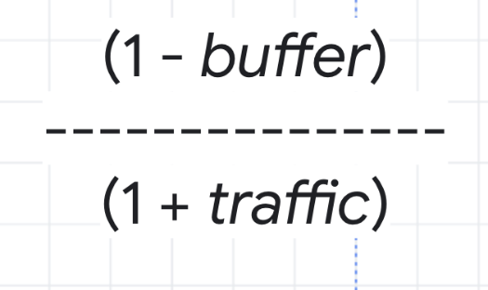
  + As an example, think about the CPU utilization for your cluster. You don't want it to hit 100%, so you could choose a buffer of 15% to keep a safe distance. Then, the traffic variable in the formula would be the percentage of traffic growth estimated in the next 2 to 3 minutes. In the load test you ran earlier, 0% to 150% was a bit of an extreme growth example, so instead imagine a more average traffic growth of 30%.
    - 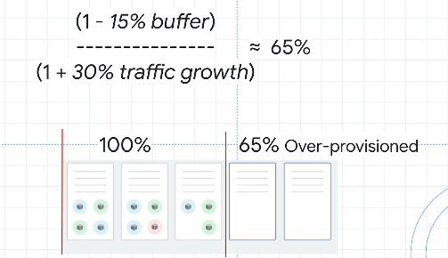
  + With these numbers, you can calculate a safety buffer of about 65%. That means you might want to over provision your resources by about 65% in order to handle scale ups while minimizing any issues.
  + An efficient strategy to overprovision a cluster with Cluster Autoscaling is to use Pause Pods.
  + **Pause Pods** are low priority deployments which are able to be removed and replaced by high priority deployments. This means you can create low priority pods which don't actually do anything except reserve buffer space. When the higher-priority pod needs room, the pause pods will be removed and rescheduled to another node, or a new node, and the higher-priority pod has the room it needs to be scheduled quickly.
  + Create a manifest for a pause pod:

cat << EOF > pause-pod.yaml

---

apiVersion: scheduling.k8s.io/v1beta1

kind: PriorityClass

metadata:

name: overprovisioning

value: -1

globalDefault: false

description: "Priority class used by overprovisioning."

---

apiVersion: apps/v1

kind: Deployment

metadata:

name: overprovisioning

namespace: kube-system

spec:

replicas: 1

selector:

matchLabels:

run: overprovisioning

template:

metadata:

labels:

run: overprovisioning

spec:

priorityClassName: overprovisioning

containers:

- name: reserve-resources

image: k8s.gcr.io/pause

resources:

requests:

cpu: 1

memory: 4Gi

EOF

* + Apply it to your cluster:
    - kubectl apply -f pause-pod.yaml
  + Now, wait a minute and then refresh the **nodes** tab of your **scaling-demo** cluster. If you're no longer on this tab, you can return there with this [link](https://console.cloud.google.com/kubernetes/clusters/details/us-central1-a/scaling-demo/nodes).
  + Observe how a new node is created, most likely in a new node pool, to fit your newly created pause pod. Now, if you were to run the load test again, when you needed an extra node for your php-apache deployment, it could be scheduled on the node with your pause pod while your pause pod is instead put on a new node. This is excellent because your dummy pause pods allow your cluster to provision a new node in advance so that your actual application can scale up much faster. If you were expecting higher amounts of traffic, you could add more pause pods, but it's considered best practice to not add more than one pause pod per node.

## 9. Application optimization for GKE - https://youtu.be/aJxxlCohVWU

* 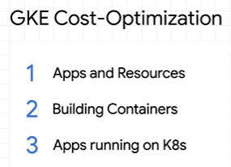
* Try running your application as a single pod replica and then test it under load without any autoscaling.
  + Once you have that information, use it to configure resource requests and limits
  + Then test your app again with cluster autoscaling and horizontal or vertical autoscaling.
  + Now test large, rapid spikes in demand to see how your app responds.
  + No matter which tool you use to stimulate demand, try to use the same region or zone as where your app is running.
  + That way you can minimize latency and focus on understanding all the details of how your app scales.
  + 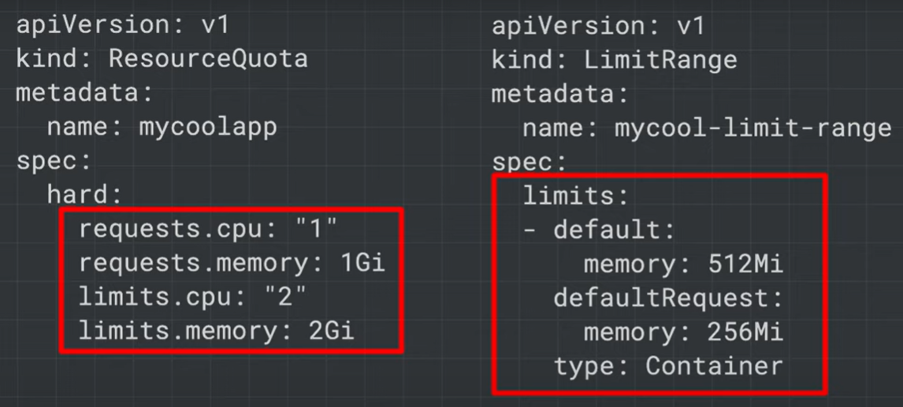
  + You can also set resource requests and use limit ranges to control resources.
  + With a resource request, you're defining how many resources your application actually needs to run.
  + With a resource limit, you're defining the maximum amount of resources that your app is allowed to use.
  + These will help Kubernetes figure out how to schedule your pods and ensure that they don't use up all the resources that are on the node.
  + 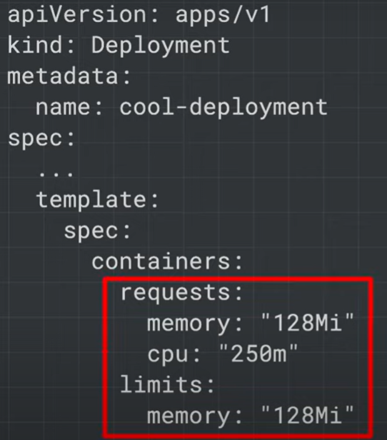
  + One best practice is to set your memory limit equal to your memory request and to set your CPU limit higher than your CPU request. Or you can even leave it unbounded.
  + Kubernetes can always throttle the CPU that your pods are using down to the request amount if the CPU resources are in high demand.
  + But the same doesn't work for memory, since Kubernetes needs to shut down pods when scaling and if there's too much demand on the memory.
* Of course, any form of autoscaling might not be very useful if your application can't scale.
  + Vertical autoscaling, it's only effective if your application can actually use the additional resources on the nodes.
  + In the same way, horizontal autoscaling is only effective if additional pod replicas actually let your app handle more demand.
* If the actual performance bottleneck is on something like a required database, more pods might actually make the problem worse.
* But if your app can't scale, you might need to consider refactoring to a structure that works well with Kubernetes.
* For example, single-threaded apps or apps that can only run a limited number of concurrent processes may not get much value out of the extra resources.
  + 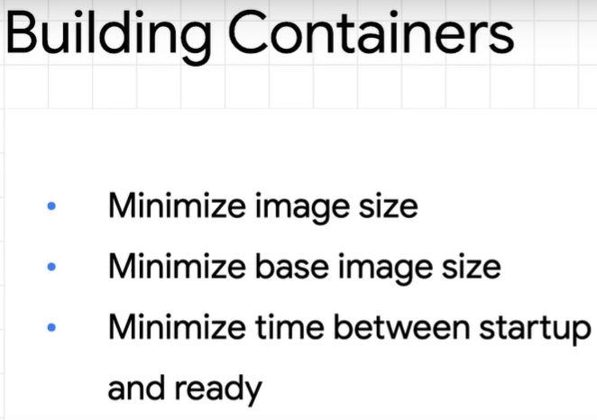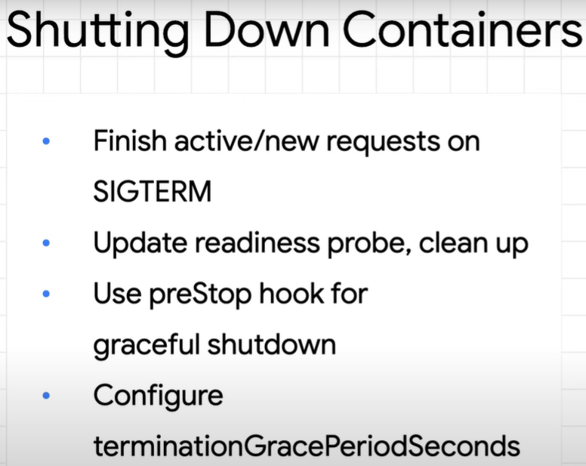
  + 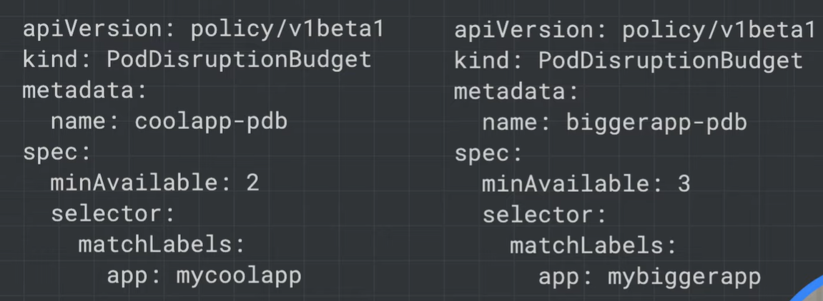
* pod disruption budgets, when you statically set the minimum number of pad replicas to keep your app running.
* Kubernetes will try to respect that number as it handles rollouts, upgrades, and autoscaling.
  + 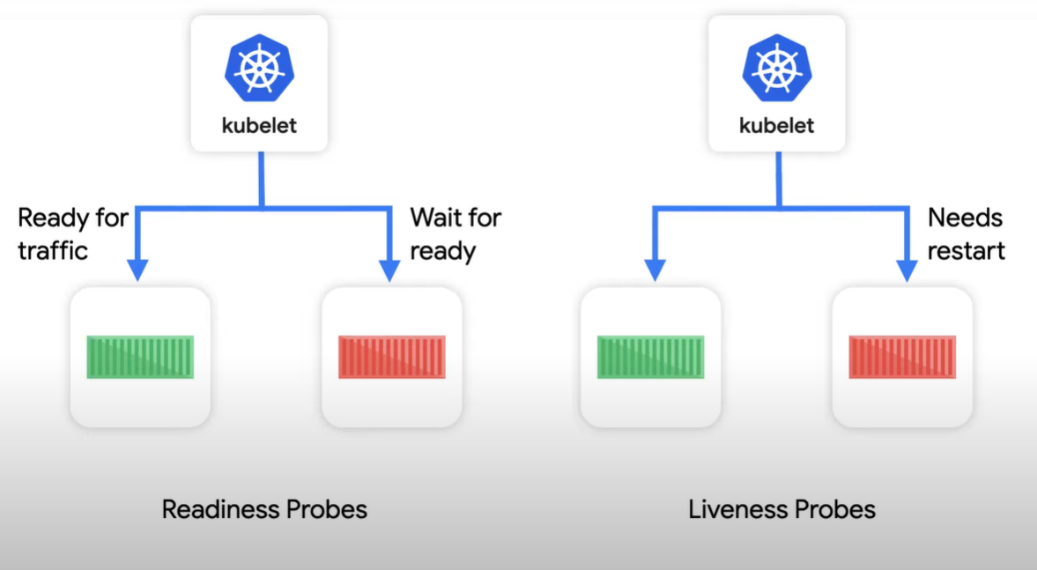
* make sure that you're correctly setting readiness and liveness probes for your app.
  + Kubernetes will use the readiness probe to know if each pod is ready to handle traffic.
  + Liveness probes are used to tell if the pod is still alive and working.
  + So if your application gets stuck or deadlocked, Kubernetes knows to restart it.
  + These two probes are key to making sure that Kubernetes can optimize working with your app.
    - 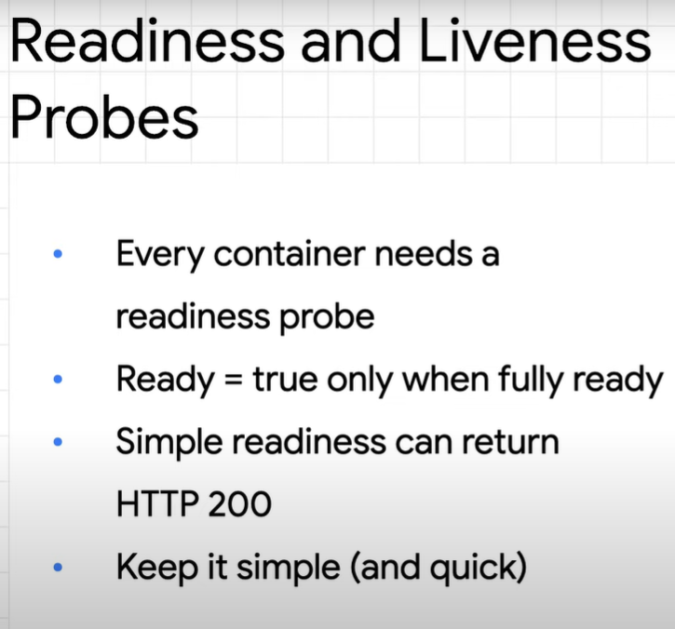

## 10. Optimize GKE to run your application - https://youtu.be/5jidVfAfru8

* 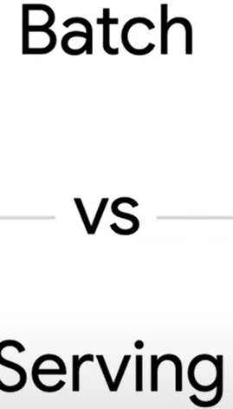
* Batch applications have work to do, but tend to be less concerned about startup time and usually aren't time-sensitive overall.
  + Apps like monthly data calculations or low priority data transformation are great examples of batch jobs.
  + As these jobs need to be scheduled, the cluster autoscaler can spin up new nodes, and then remove them when the job is done.
  + Even better, node autoprovisioning works best with batch workloads since it can figure out optimal resources, and then create a new node pool, and doesn't need to worry as much about spikes in demand.
  + 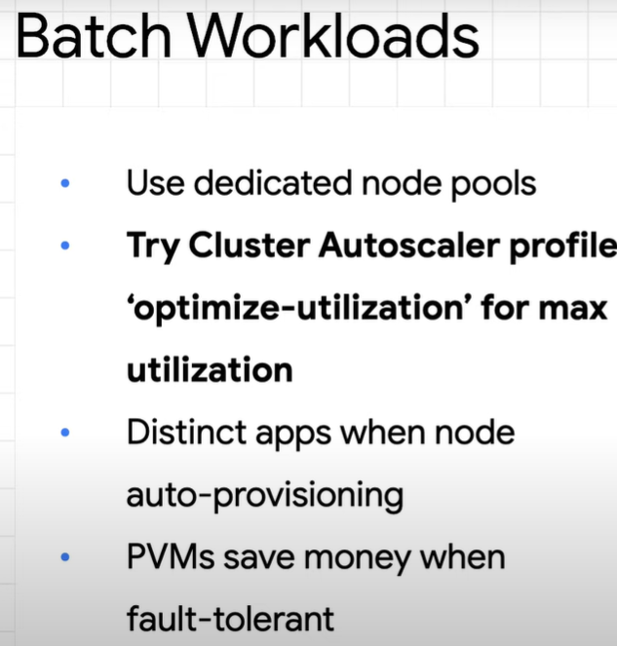
* serving apps, which need the ability to scale rapidly in response to spikes in demand--
  + for example, a retail website on major shopping holidays.
  + In order to handle the sudden increases in demand, it's good for serving workloads to be lean and optimized to work best with GKE.
  + The quicker that pods can start up, the more efficient autoscalers are at responding to demand.
  + If you have a serving app that requires resources with a long provisioning time, like, GPUs, it makes sense to overprovision and have resources at the ready before the demand spikes.
  + Plus, you can use pause pods to help you scale ahead.
* Make sure to use NodeLocal DNSCaching. If you're running a version with kube-dns, apps that make a lot of DNS lookups will put extra pressure on it.
  + While the kube-dns autoscaler will create more kube-dns replicas, it takes time to add those replicas and increases resource usage.
  + Instead of just increasing the kube-dns replicas in your configuration, add the NodeLocal DNSCache add-on.
  + Each node will then store a DNS cache, which helps kube-dns require less resources and saves overall time for lookups.
* On top of that, round-trip request time is usually better when it's low.
  + One tip for lowering this is to use container-native load balancing.
  + Rather than sending requests to instance groups and then pods, container-native load balancing allows requests to go directly to the pod by creating what's called a Network Endpoint Group.
    - 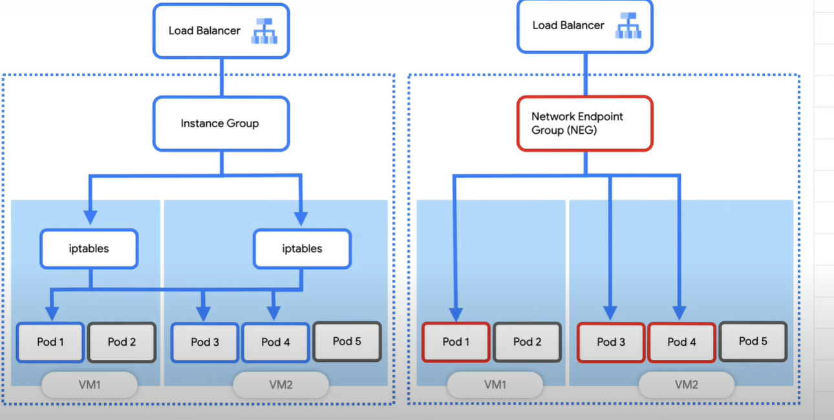
  + When these are configured, GKE Ingress will handle the creation of the L7 load balancer, along with forwarding rules, health checks, firewalls, and more.

## 11. GKE Workload Optimization - https://www.cloudskillsboost.google/focuses/15706?parent=catalog

* Overview
  + One of the many benefits of using Google Cloud is its billing model that bills you for only the resources you use. With that in mind, it's imperative that you not only allocate a reasonable amount of resources for your apps and infrastructure, but that you make the most efficient use of them. With GKE there are a number of tools and strategies available to you that can reduce the use of different resources and services while also improving your application's availability.
  + This lab will walk through a few concepts that will help increase the resource efficiency and availability of your workloads. By understanding and fine-tuning your cluster's workload, you can better ensure you are only using the resources you need and optimizing your cluster's costs.
* **What you'll do**
  + Configure container-native load balancing for load balancing through ingress for more efficient routing to your pods
  + Walk through a single-pod load test of a Kubernetes application for understanding app load capacity
  + Configure a liveness probe for a Kubernetes application in order to define meaningful prerequisite conditions for automatic pod reboots
  + Configure a readiness probe for a Kubernetes application in order to ensure that traffic reaches the application endpoints successfully
  + Configure a Pod Disruption Budget for ensuring application availability
* **Provision Lab Environment**
  + Set your default zone to us-central1-a:
    - gcloud config set compute/zone us-central1-a
  + Create a three node cluster:
    - gcloud container clusters create test-cluster --num-nodes=3 --enable-ip-alias
  + The --enable-ip-alias flag is included in order to enable the use of alias IPs for pods which will be required for container-native load balancing through an ingress.
  + For this lab, you'll use a simple HTTP web app that you will first deploy as a single pod.
  + Create a manifest for the gb-frontend pod:

cat << EOF > gb_frontend_pod.yaml

apiVersion: v1

kind: Pod

metadata:

labels:

app: gb-frontend

name: gb-frontend

spec:

containers:

- name: gb-frontend

image: gcr.io/google-samples/gb-frontend:v5

resources:

requests:

cpu: 100m

memory: 256Mi

ports:

- containerPort: 80

EOF

* + Apply the newly created manifest to your cluster:
    - kubectl apply -f gb_frontend_pod.yaml
* Container-native Load Balancing Through Ingress
  + Container-native load balancing allows load balancers to target Kubernetes Pods directly and to evenly distribute traffic to pods.
  + Without container-native load balancing, load balancer traffic would travel to node instance groups and then be routed via iptables rules to pods which may or may not be in the same node:
    - 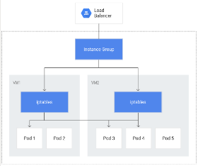
  + Container-native load balancing allows pods to become the core objects for load balancing, potentially reducing the number of network hops:
    - 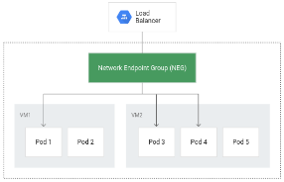
  + In addition to more efficient routing, container-native load balancing results in substantially reduced network utilization,improved performance, even distribution of traffic across Pods, and application-level health checks.
  + In order to take advantage of container-native load balancing, the VPC-native setting must be enabled on the cluster. This was indicated when you created the cluster and included the --enable-ip-alias flag.
  + The following manifest will configure a ClusterIP service that will be used to route traffic to your application pod to allow GKE to create a network endpoint group:

cat << EOF > gb_frontend_cluster_ip.yaml

apiVersion: v1

kind: Service

metadata:

name: gb-frontend-svc

annotations:

cloud.google.com/neg: '{"ingress": true}'

spec:

type: ClusterIP

selector:

app: gb-frontend

ports:

- port: 80

protocol: TCP

targetPort: 80

EOF

* + The manifest includes an annotations field where the annotation for cloud.google.com/neg will enable container-native load balancing on for your application when an ingress is created.
  + Apply the change to your cluster:
    - kubectl apply -f gb_frontend_cluster_ip.yaml
  + Next, create an ingress for your application:

cat << EOF > gb_frontend_ingress.yaml

apiVersion: networking.k8s.io/v1beta1

kind: Ingress

metadata:

name: gb-frontend-ingress

spec:

backend:

serviceName: gb-frontend-svc

servicePort: 80

EOF

* + Apply the change to your cluster:
    - kubectl apply -f gb_frontend_ingress.yaml
  + When the ingress is created, an HTTP(S) load balancer is created along with an NEG (Network Endpoint Group) in each zone in which the cluster runs. After a few minutes, the ingress will be assigned an external IP.
  + The load balancer it created has a backend service running in your project that defines how Cloud Load Balancing distributes traffic. This backend service has a health status associated with it. To check the health status of the backend service, first retrieve the name:
    - BACKEND_SERVICE=$(gcloud compute backend-services list | grep NAME | cut -d ' ' -f2)
  + Get the health status for the service:
    - gcloud compute backend-services get-health $BACKEND_SERVICE --global
  + Output will look something like this:

---

backend: https://www.googleapis.com/compute/v1/projects/app-load-testing/zones/us-central1-a/networkEndpointGroups/k8s1-39f2f5d5-default-gb-frontend-80-4b514170

status:

healthStatus:

- healthState: HEALTHY

instance: https://www.googleapis.com/compute/v1/projects/app-load-testing/zones/us-central1-a/instances/gke-test-cluster-default-pool-0274c043-8bc4

ipAddress: 10.0.1.23

port: 80

- healthState: HEALTHY

instance: https://www.googleapis.com/compute/v1/projects/app-load-testing/zones/us-central1-a/instances/gke-test-cluster-default-pool-0274c043-0zn2

ipAddress: 10.0.0.27

port: 80

kind: compute#backendServiceGroupHealth

* + These health checks are part of the Google Cloud load balancer and are distinct from the liveness and readiness probes provided by the Kubernetes API which can be used to determine the health of individual pods. The Google Cloud load balancer health checks use special routes outside of your project’s VPC to perform health checks and determine the success or failure of a backend.
  + Once the health state for each instance reports as HEALTHY, you can access the application via its external IP. Retrieve it with:
    - kubectl get ingress gb-frontend-ingress
  + Entering the external IP in a browser window will load the application.
* Load Testing an Application
  + Understanding your application capacity is an important step to take when choosing resource requests and limits for your application's pods and for deciding the best auto-scaling strategy.
  + At the start of the lab, you deployed your app as a single pod. By load testing your application running on a single pod with no autoscaling configured, you will learn how many concurrent requests your application can handle, how much CPU and memory it requires, and how it might respond to heavy load.
  + To load test your pod, you'll use Locust, an open source load-testing framework. Download the Docker image files for Locust in your Cloud Shell:
    - gsutil cp -r gs://spls/gsp769/locust-image .
  + The files in the provided locust-image directory include Locust configuration files. Build the Docker image for Locust and store it in your project's container registry:
    - gcloud builds submit --tag gcr.io/${GOOGLE_CLOUD_PROJECT}/locust-tasks:latest locust-image
  + Verify the Docker image is in your project's container registry:
    - gcloud container images list
  + Expected output:
    - 
  + Locust consists of a main and a number of worker machines to generate load. Copy and apply the manifest will create a single-pod deployment for the main and a 5-replica deployment for the workers:
    - gsutil cp gs://spls/gsp769/locust_deploy_v2.yaml .
    - sed 's/${GOOGLE_CLOUD_PROJECT}/'$GOOGLE_CLOUD_PROJECT'/g' locust_deploy_v2.yaml | kubectl apply -f -
  + To access the Locust UI, retrieve the external IP address of its corresponding LoadBalancer service:
    - kubectl get service locust-main
  + If your **External IP** value is **<pending>**, wait a minute and rerun the previous command until a valid value is displayed.
  + In a new browser window, navigate to [EXTERNAL_IP_ADDRESS]:8089:
    - 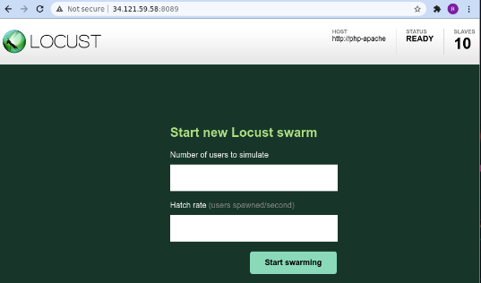
  + Locust allows you to swarm your application with many simultaneous users. You are able to simulate traffic by entering a number of users that are spawned at a certain rate.
  + For this example, to represent a typical load, enter **200** for the number of users to simulate and **20** for the hatch rate. After a few seconds, the **status** should read **Running** with 200 users and about 150 requests per second (RPS):
    - 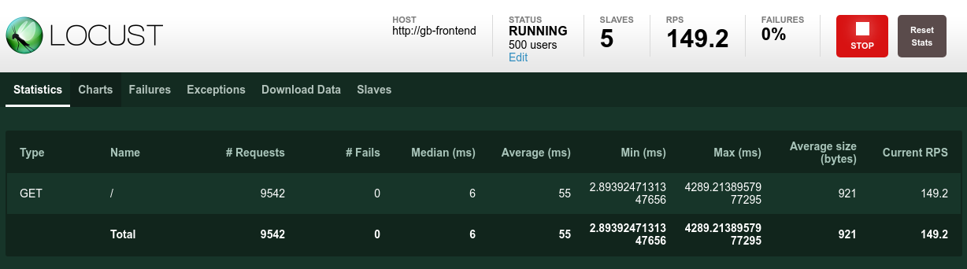
  + Switch to the Cloud Console and from the Navigation menu click Kuberentes Engine:
  + Select **Workloads** from the left pane:
  + Then click on your deployed **gb-frontend** pod:
  + This will bring you to the pod details page where you can view a graph of the CPU and memory utilization of your pod. Observe the **used** values and the **requested** values:
    - 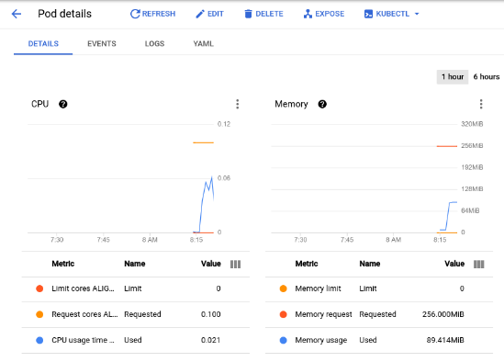
  + In order to see the metric values listed below the graph, click the three dots at the top right portion of the graph and select **Toggle the legend display** from the dropdown.
  + With the current load test at about 150 requests per second, you may see the CPU utilization vary from as low as **.04** and as high as **.06.** This represents **40-60%** of your one pod's CPU request. On the other hand, memory utilization stays at around **80Mi**, well below the requested 256Mi. This is your **per-pod capacity**. This information will be useful when configuring your Cluster Autoscaler, resource requests and limits, and choosing how or whether to implement a horizontal or vertical pod autoscaler.
  + Along with a baseline, you should also take into account how your application may perform after sudden bursts or spikes.
  + Return to the Locust browser window and click **Edit** under the status at the top of the page. This time, enter **900** for the number of users to simulate and **300** for the hatch rate and click **Start Swarming**.
  + Your pod will suddenly receive 700 additional requests within 2 - 3 seconds. After the RPS value reaches about 150 and the status indicates 900 users, switch back to the **Pod Details page** and observe the change in the graphs:
    - 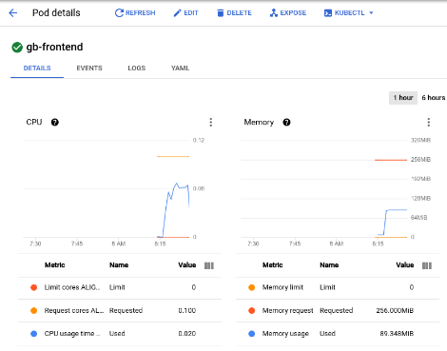
  + While memory stayed the same you'll see that CPU peaked at almost .07 - that's 70% of the CPU request for your pod. If this app were a deployment, you could probably safely reduce the total memory request to a lower amount and configure your horizontal autoscaler to trigger on CPU usage.
* Readiness and Liveness Probes
  + **Setting up a liveness probe**
    - If configured in the Kubernetes pod or deployment spec, a liveness probe will continuously run to detect whether a container requires a restart and trigger that restart. They are helpful for automatically restarting deadlocked applications that may still be in a running state. For example, a kubernetes-managed load balancer (such as a service) would only send traffic to a pod backend if all of its containers pass a readiness probe.
    - To demonstrate a liveness probe, the following will generate a manifest for a pod that has a liveness probe based on the execution of the cat command on a file created on creation:

cat << EOF > liveness-demo.yaml

apiVersion: v1

kind: Pod

metadata:

labels:

demo: liveness-probe

name: liveness-demo-pod

spec:

containers:

- name: liveness-demo-pod

image: centos

args:

- /bin/sh

- -c

- touch /tmp/alive; sleep infinity

livenessProbe:

exec:

command:

- cat

- /tmp/alive

initialDelaySeconds: 5

periodSeconds: 10

EOF

* + - The initialDelaySeconds value represents how long before the first probe should be performed after the container starts up. The periodSeconds value indicates how often the probe will be performed.
    - Pods can also be configured to include a startupProbe which indicates whether the application within the container is started. If a startupProbe is present, no other probes will perform until it returns a Success state. This is recommended for applications that may have variable start-up times in order to avoid interruptions from a liveness probe.
    - In this example the liveness probe is essentially checking if the file /tmp/alive exists on the container's file system. You can verify the health of the pod's container by checking the pod's events:
      * kubectl describe pod liveness-demo-pod
    - At the bottom of the output there should be an Events section with the pod's last 5 events. At this point, the pod's events should only include the events related to its creation and start up:

Events:

Type Reason Age From Message

---- ------ ---- ---- -------

Normal Scheduled 19s default-scheduler Successfully assigned default/liveness-demo-pod to gke-load-test-default-pool-abd43157-rgg0

Normal Pulling 18s kubelet Pulling image "centos"

Normal Pulled 18s kubelet Successfully pulled image "centos"

Normal Created 18s kubelet Created container liveness-demo-pod

Normal Started 18s kubelet Started container liveness-demo-pod

* + - This events log will include any failures in the liveness probe as well as restarts triggered as a result. Manually delete the file being used by the liveness probe:
      * kubectl exec liveness-demo-pod -- rm /tmp/alive
    - With the file removed, the cat command being used by the liveness probe should return a non-zero exit code. Once again, check the pod's events:
      * kubectl describe pod liveness-demo-pod
    - As the liveness probe fails, you'll see events added to the log showing the series of steps that are kicked off. It will begin with the liveness probe failing (Liveness probe failed: cat: /tmp/alive: No such file or directory) and end with the container starting up once again (Started container):

Events:

Type Reason Age From Message

---- ------ ---- ---- -------

Normal Scheduled 2m21s default-scheduler Successfully assigned default/liveness-demo-pod to gke-load-test-default-pool-abd43157-rgg0

Warning Unhealthy 36s (x3 over 56s) kubelet Liveness probe failed: cat: /tmp/alive: No such file or directory

Normal Killing 36s kubelet Container liveness-demo-pod failed liveness probe, will be restarted

Normal Pulling 6s (x2 over 2m20s) kubelet Pulling image "centos"

Normal Pulled 6s (x2 over 2m20s) kubelet Successfully pulled image "centos"

Normal Created 6s (x2 over 2m20s) kubelet Created container liveness-demo-pod

Normal Started 6s (x2 over 2m20s) kubelet Started container liveness-demo-pod

* + - The example in this lab uses a command probe for its livenessProbe that depends on the exit code of a specified command. In addition to a command probe, a livenessProbe could be configured as an**HTTP probe**that will depend on HTTP response, or a **TCP probe**that will depend on whether a TCP connection can be made on a specific port.
  + **Setting up a readiness probe**
    - Although a pod could successfully start and be considered healthy by a liveness probe, it's likely that it may not be ready to receive traffic right away. This is common for deployments that serve as a backend to a service such as a load balancer. A **readiness probe** is used to determine when a pod and its containers are ready to begin receiving traffic.
    - To demonstrate this, create a manifest to create a single pod that will serve as a test webserver along with a load balancer:

cat << EOF > readiness-demo.yaml

apiVersion: v1

kind: Pod

metadata:

labels:

demo: readiness-probe

name: readiness-demo-pod

spec:

containers:

- name: readiness-demo-pod

image: nginx

ports:

- containerPort: 80

readinessProbe:

exec:

command:

- cat

- /tmp/healthz

initialDelaySeconds: 5

periodSeconds: 5

---

apiVersion: v1

kind: Service

metadata:

name: readiness-demo-svc

labels:

demo: readiness-probe

spec:

type: LoadBalancer

ports:

- port: 80

targetPort: 80

protocol: TCP

selector:

demo: readiness-probe

EOF

* + - Apply the manifest to your cluster and create a load balancer with it:
      * kubectl apply -f readiness-demo.yaml
    - Retrieve the external IP address assigned to your load balancer (it may take a minute after the previous command for an address to be assigned):
      * kubectl get service readiness-demo-svc
    - Enter the IP address in a browser window and you'll notice that you'll get an error message signifying that the site cannot be reached. Check the pod's events:
      * kubectl describe pod readiness-demo-pod
    - The output will reveal that the readiness probe has failed:

Events:

Type Reason Age From Message

---- ------ ---- ---- -------

Normal Scheduled 2m24s default-scheduler Successfully assigned default/readiness-demo-pod to gke-load-test-default-pool-abd43157-rgg0

Normal Pulling 2m23s kubelet Pulling image "nginx"

Normal Pulled 2m23s kubelet Successfully pulled image "nginx"

Normal Created 2m23s kubelet Created container readiness-demo-pod

Normal Started 2m23s kubelet Started container readiness-demo-pod

Warning Unhealthy 35s (x21 over 2m15s) kubelet Readiness probe failed: cat: /tmp/healthz: No such file or directory

* + - Unlike the liveness probe, an unhealthy readiness probe does not trigger the pod to restart. Use the following command to generate the file that the readiness probe is checking for:
      * kubectl exec readiness-demo-pod -- touch /tmp/healthz
    - The Conditions section of the pod description should now show True as the value for Ready.
      * kubectl describe pod readiness-demo-pod | grep ^Conditions -A 5
    - Output:

Conditions:

Type Status

Initialized True

Ready True

ContainersReady True

PodScheduled True

* + - Now, refresh the browser tab that had your **readiness-demo-svc** external IP. You should see a "**Welcome to nginx!"** message properly displayed.
    - Setting meaningful readiness probes for your application containers ensures that pods are only receiving traffic when they are ready to do so. An example of a meaningful readiness probe is checking to see whether a cache your application relies on is loaded at startup.
* Pod Disruption Budgets
  + Part of ensuring reliability and uptime for your GKE application relies on leveraging pod disruption budgets (pdp). PodDisruptionBudget is a Kubernetes resource that limits the number of pods of a replicated application that can be down simultaneously due to voluntary disruptions. Voluntary disruptions include administrative actions like deleting a deployment, updating a deployment's pod template and performing a rolling update, draining nodes that an application's pods reside on, or moving pods to different nodes.
  + First, you'll have to deploy your application as a deployment. Delete your single pod app:
    - kubectl delete pod gb-frontend
  + And generate a manifest that will create it as a deployment of 5 replicas:

cat << EOF > gb_frontend_deployment.yaml

apiVersion: apps/v1

kind: Deployment

metadata:

name: gb-frontend

labels:

run: gb-frontend

spec:

replicas: 5

selector:

matchLabels:

run: gb-frontend

template:

metadata:

labels:

run: gb-frontend

spec:

containers:

- name: gb-frontend

image: gcr.io/google-samples/gb-frontend:v5

resources:

requests:

cpu: 100m

memory: 128Mi

ports:

- containerPort: 80

protocol: TCP

EOF

* + Apply this deployment to your cluster:
    - kubectl apply -f gb_frontend_deployment.yaml
  + Before creating a PDB, you will drain your cluster's nodes and observe your application's behavior without a PDB in place.
  + Drain the nodes by looping through the output of the default-pool's nodes and running the kubectl drain command on each individual node:

for node in $(kubectl get nodes -l cloud.google.com/gke-nodepool=default-pool -o=name); do

kubectl drain --force --ignore-daemonsets --grace-period=10 "$node";

done

* + The command above will evict pods from the specified node and cordon the node so that no new pods can be created on it. If the available resources allow, pods are redeployed on a different node. Once your node has been drained, check in on your gb-frontend deployment's replica count:
    - kubectl describe deployment gb-frontend | grep ^Replicas
  + The output may resemble something like this:
    - Replicas: 5 desired | 5 updated | 5 total | 0 available | 5 unavailable
  + After draining a node, your deployment could have as little as 0 replicas available, as indicated by the output above. Without any pods available, your application is effectively down. Let's try draining the nodes again, except this time with a pod disruption budget in place for your application.
  + First bring the drained nodes back by uncordoning them. The command below allows pods to be scheduled on the node again:

for node in $(kubectl get nodes -l cloud.google.com/gke-nodepool=default-pool -o=name); do

kubectl uncordon "$node";

done

* + Once again check in on the status of your deployment:
    - kubectl describe deployment gb-frontend | grep ^Replicas
  + The output should now resemble the following, with all 5 replicas available:
    - Replicas: 5 desired | 5 updated | 5 total | 5 available | 0 unavailable
  + Create a pod disruption budget that will declare the minimum number of available pods to be 4:
    - kubectl create poddisruptionbudget gb-pdb --selector run=gb-frontend --min-available 4
  + Once again, drain one of your cluster's nodes and observe the output:

for node in $(kubectl get nodes -l cloud.google.com/gke-nodepool=default-pool -o=name); do

kubectl drain --timeout=30s --ignore-daemonsets --grace-period=10 "$node";

done

* + After successfully evicting one of your application's pods, it will loop through the following:

evicting pod default/gb-frontend-597d4d746c-fxsdg

evicting pod default/gb-frontend-597d4d746c-tcrf2

evicting pod default/gb-frontend-597d4d746c-kwvmv

evicting pod default/gb-frontend-597d4d746c-6jdx5

error when evicting pod "gb-frontend-597d4d746c-fxsdg" (will retry after 5s): Cannot evict pod as it would violate the pod's disruption budget.

error when evicting pod "gb-frontend-597d4d746c-tcrf2" (will retry after 5s): Cannot evict pod as it would violate the pod's disruption budget.

error when evicting pod "gb-frontend-597d4d746c-6jdx5" (will retry after 5s): Cannot evict pod as it would violate the pod's disruption budget.

error when evicting pod "gb-frontend-597d4d746c-kwvmv" (will retry after 5s): Cannot evict pod as it would violate the pod's disruption budget.

* + Enter CTL+C to exit the command. Check your deployments status once again:
    - kubectl describe deployment gb-frontend | grep ^Replicas
  + The output should now read:
    - Replicas: 5 desired | 5 updated | 5 total | 4 available | 1 unavailable
* Until Kuberentes is able to deploy a 5th pod on a different node in order to evict the next one, the remaining pods will remain available in order to adhere to the PDB. In this example, the pod disruption budget was configured to indicate **min-available** but a PDB can also be configured to define a **max-unavailable**. Either value can be expressed as an integer representing a pod count, or a percentage of total pods.

## 12. Optimize Costs for Google Kubernetes Engine: Challenge Lab - https://www.cloudskillsboost.google/focuses/16327?parent=catalog

* Overview
  + given a scenario and a set of tasks. Instead of following step-by-step instructions, you will use the skills learned from the labs in the quest to figure out how to complete the tasks on your own! An automated scoring system (shown on this page) will provide feedback on whether you have completed your tasks correctly.
* Topics tested:
  + Deploying an app on a multi-tenant cluster
  + Migrating cluster workloads to an optimized node pool
  + Rolling out an application update while maintaining cluster availability
  + Cluster and pod autoscaling
* Challenge Scenario:
  + You are the lead Google Kubernetes Engine admin on a team that manages the online shop for **OnlineBoutique**.
  + You are ready to deploy your team's site to Google Kubernetes Engine but you are still looking for ways to make sure that you're able to keep costs down and performance up.
  + You will be responsible for deploying the **OnlineBoutique** app to GKE and making some configuration changes that have been recommended for cost optimization.
  + Here are some guidelines you've been requested to follow when deploying:
    - Create the cluster in the us-central1 region
    - The naming scheme is team-resource-number, e.g. a cluster could be named Cluster Name
    - For your initial cluster, start with machine size n1-standard-2 (2 vCPU, 8G memory)
    - Set your cluster to use the **rapid** release-channel.
* **Task 1: Create our cluster and deploy our app**
  + Before you can deploy the application, you'll need to create a cluster and name it as Cluster Name . Start small and make a zonal cluster with only two (2) nodes.
  + Before you deploy the shop, make sure to set up some namespaces to separate resources on your cluster in accordance with the 2 environments - dev and prod.
  + After that, deploy the application to the dev namespace with the following command:
    - git clone https://github.com/GoogleCloudPlatform/microservices-demo.git &&
    - cd microservices-demo && kubectl apply -f ./release/kubernetes-manifests.yaml --namespace dev
  + You can check that your **OnlineBoutique**store is up and running by navigating to the IP address for your **frontend-external** service.
  + Solution
    - gcloud config set compute/zone us-central1-a
    - gcloud container clusters create onlineboutique-cluster-876 --num-nodes=2 --machine-type=n1-standard-2
    - kubectl create namespace dev && kubectl create namespace prod
    - kubectl config set-context --current --namespace dev
    - git clone https://github.com/GoogleCloudPlatform/microservices-demo.git &&
    - cd microservices-demo && kubectl apply -f ./release/kubernetes-manifests.yaml --namespace dev
    - kubectl get svc -w --namespace dev
    - http://<External IP for frontend-external service>

### **Task 2: Migrate to an Optimized Nodepool**

* + After successfully deploying the app to the dev namespace, take a look at the node details:
    - 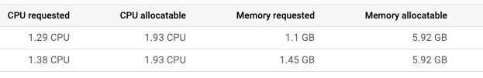
  + You come to the conclusion that you should make changes to the cluster's node pool:
    - There's plenty of left over RAM from the current deployments so you should be able to use a nodepool with machines that offer **less RAM**
    - Most of the deployments that you might consider increasing the replica count of will require only 100mcpu per additional pod. You could potentially use a nodepool with **less total CPU** if you configure it to use smaller machines. However, you also need to consider how many deployments will need to scale, and how much they need to scale by.
  + Create a new node pool named Pool Name with **custom-2-3584** as the machine type. Set the **number of nodes** to **2**.
  + Once the new nodepool is set up, migrate your application's deployments to the new nodepool by **cordoning off and draining** default-pool. **Delete** the default-pool once the deployments have safely migrated.
  + Solution
    - gcloud container node-pools create optimized-pool-4961 --cluster=onlineboutique-cluster-876 --machine-type=custom-2-3584 --num-nodes=2 --zone=us-central1-a
    - for node in $(kubectl get nodes -l cloud.google.com/gke-nodepool=default-pool -o=name); do kubectl cordon "$node"; done
    - for node in $(kubectl get nodes -l cloud.google.com/gke-nodepool=default-pool -o=name); do kubectl drain --force --ignore-daemonsets --delete-local-data --grace-period=10 "$node"; done
    - kubectl get pods -o=wide --namespace dev
    - gcloud container node-pools delete default-pool --cluster onlineboutique-cluster-876 --zone us-central1-a

### **Task 3: Apply a Frontend Update**

* + You just got it all deployed, and now the dev team wants you to push a last-minute update before the upcoming release! That's ok. You know this can be done without the need to cause down time.
  + Set a pod disruption budget for your **frontend** deployment. Name it **onlineboutique-frontend-pdb** and set the **min-availability** of your deployment to **1**.
  + Now, you can apply your team's update. They've changed the file used for the home page's banner and provided you an updated docker image:
  + gcr.io/qwiklabs-resources/onlineboutique-frontend:v2.1
  + **Edit** your **frontend** deployment and change its image to the updated one.
  + **Solution**
    - kubectl create poddisruptionbudget onlineboutique-frontend-pdb --selector run=frontend --min-available 1
    - export KUBE_EDITOR="nano"
    - kubectl edit deployment frontend --namespace=dev
    - Edit your frontend deployment and change its image to the updated one
      * gcr.io/qwiklabs-resources/onlineboutique-frontend:v2.1
      * imagePullPolicy to Always
    - Press ctrl + X, Y and Enter to save and exit.

### **Task 4: Autoscale from Estimated Traffic**

* + A marketing campaign is coming up that will cause a traffic surge on the OnlineBoutique shop. Normally, you would spin up extra resources in advance to handle the estimated traffic spike. However, if the traffic spike is larger than anticipated, you may get woken up in the middle of the night to spin up more resources to handle the load. You also want to avoid running extra resources for any longer than necessary. To both lower costs and save yourself a potential headache, you can configure the Kubernetes deployments to scale automatically when the load begins to spike.
  + Apply **horizontal pod autoscaling** to your **frontend deployment** in order to handle the traffic surge. Scale based off a target cpu percentage of 50 and set the pod scaling between 1 minimum and Max Replicas maximum.
  + Of course, you want to make sure that users won’t experience downtime while the deployment is scaling. To make sure the scaling action occurs without downtime, set the deployment to scale with a target cpu percentage of 50%. This should allow plenty of space to handle the load as the autoscaling occurs. Set the deployment to scale between 1 minimum and Max Replicas maximum pods.
  + But what if the spike exceeds the compute resources you currently have provisioned? You may need to add additional compute nodes. Next, ensure that your cluster is able to automatically spin up additional compute nodes if necessary. However, handling scaling up isn’t the only case you can handle with autoscaling. Thinking ahead, you configure both a minimum number of nodes, and a maximum number of nodes. This way, the cluster can add nodes when traffic is high, and reduce the number of nodes when traffic is low.
  + Update your **cluster autoscaler** to scale between **1 node minimum** and **6 nodes maximum**.
  + Lastly, run a load test to simulate the traffic surge.
  + Fortunately, **OnlineBoutique** was designed with built-in load generation. Currently, your dev instance is simulating traffic on the store with ~10 concurrent users.
  + In order to better replicate the traffic expected for this event, run the load generation from your loadgenerator pod with a higher number of concurrent users with this command. Replace **YOUR_FRONTEND_EXTERNAL_IP** with the IP of the frontend-external service:
    - kubectl exec $(kubectl get pod --namespace=dev | grep 'loadgenerator' | cut -f1 -d ' ') -it --namespace=dev -- bash -c "export USERS=8000; locust --host="http://YOUR_FRONTEND_EXTERNAL_IP" --headless -u "8000" 2>&1"
  + Now, observe your **Workloads** and monitor how your cluster handles the traffic spike.
  + You should see your recommendationservice crashing or, at least, heavily struggling from the increased demand.
  + Apply **horizontal pod autoscaling** to your **recommendationservice** deployment. Scale based off a target cpu percentage of 50 and set the pod scaling between 1 minimum and 5 maximum.
  + Note: The process of scaling from the load test and having to provision any new nodes will take a couple of minutes altogether.
  + Solution
    - kubectl autoscale deployment frontend --cpu-percent=50 --min=1 --max=12 --namespace dev
    - kubectl get hpa --namespace dev
    - gcloud beta container clusters update onlineboutique-cluster-876 --enable-autoscaling --min-nodes 1 --max-nodes 6
    - kubectl get pods --namespace=dev
    - kubectl exec $(kubectl get pod --namespace=dev | grep 'loadgenerator' | cut -f1 -d ' ') -it --namespace=dev -- bash -c "export USERS=8000; locust --host="http://34.122.252.21/" --headless -u "8000" 2>&1"

### **Task 5 [OPTIONAL]: Optimize Other Services**

* + While applying horizontal pod autoscaling to your frontend service keeps your application available during the load test, if you monitor your other workloads, you'll notice that some of them are being pushed heavily for certain resources.
  + If you still have time left in the lab, inspect some of your other workloads and try to optimize them by applying autoscaling towards the proper resource metric.
  + You can also see if it would be possible to further optimize your resource utilization with **Node Auto Provisioning**.